ACTIVE SCHOOLS SUMMER PROGRAMME

P1-7 Multi-Sports Activity Programme:-

Wednesday 12th July to Friday 14th July
10am – 1pm each day @ Kemnay Academy
Cost = £6 per day, or 3 days for £15

Hip Hop with MC:-

Monday 17th July
P1-3: 11:30am-12:30pm , P4-7: 12:30pm-2pm
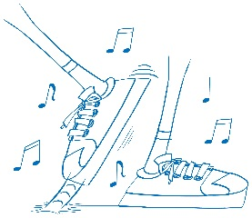
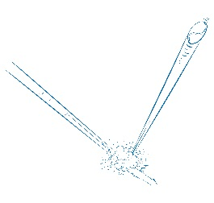
@Kemnay Academy
Cost = £3 (P1-3), £4 (P4-7)

Tennis:-

Monday 24th July to Thursday 27th July
P1-2: 10am-11am , P3-4: 11am-12pm , P5-7: 12pm-1:30pm each day @ Kemnay Tennis Courts
Cost = £3 per session (P1-4), £4 per session (P5-7)

Judo and Games with Garioch Judo Club:-

Tuesday 1st August
P1-7 – 9:30am-12:30pm @ Kemnay Academy
Cost = £6

For information regarding booking, please see reverse of leaflet.

Spaces are limited and must be booked before Friday 7th July!!

Booking Procedure:-

In order for your child to attend the holiday programme activity sessions you must ensure you sign up via one of the following methods:

Online application form: http://www.aberdeenshire.gov.uk/request/active-schools/active-schools-online-form-garioch-holiday-programme/

Call: Lynsey Coutts on 01467 538899 / 07909 875461
or Email: lynsey.coutts@aberdeenshire.gov.uk

*If your child has previously attended an Active Schools club/session, and contact details have not changed, then please call or email to book your child’s space at the programme*

Payment:

Please bring payment in a sealed envelope with your child’s name and school clearly marked on the front. Please bring payment on the first day your child is attending the programme.
Cheques can be made payable to “Aberdeenshire Council”.
*Free to Active Aberdeenshire Members*

