na00862_

**Term 1 Primary 3P Newsletter ☺**

Dear Parents / Guardians,

My name is Miss Ritchie and I am delighted to be teaching Primary 3P this year. I am very pleased at how well all the children have settled into the class over the last couple of weeks, and I am looking forward to working together with you and your child over the year ahead. Below I have summarised some important information for you and your child regarding this term.

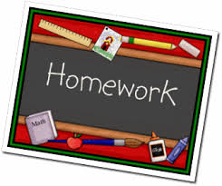**Homework**Homework will be issued on a **Wednesday** and is expected to be completed and returned the following **Tuesday.** The class are also required to read their reading book in school three times a week. The pages they are required to read for homework will be recorded in their home-school diary (see below).

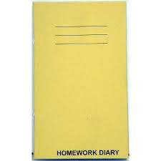**Home-School Diary**Each child will have a home-school diary and this will be used to communicate the children’s reading homework for the week. Can I please ask that you check and sign your child’s home-school diary to show that you have seen are happy with the homework they have produced.

**Timetable**  
This term P3P are very fortunate in that they will benefit from exciting learning experiences in class and with our visiting specialists. Please note that timings and specialists are likely to change throughout the year to ensure your child has a rounded experience of different curricular areas. The current schedule is as follows:

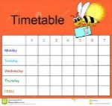  
**Monday -** ICT with Mr Wilson   
**Tuesday** - Drama with Mrs McGillivray   
**Wednesday** - PE with Class Teacher, Library every second week (30.08.17, 13.09.17, 27.09.17 and 11.10.17)   
**Thursday** – Kodaly with Mrs Okumu and Singing with Mrs Minto   
**Friday** – Assembly, PE with class teacher and Excellence Time

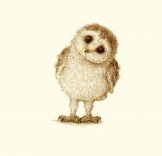**Topic**This term we are starting with a mini book study based on the book ‘*The Owl who was Afraid of the Dark’* by Jill Tomlinson. We have been looking at the children’s likes and dislikes about the dark, nocturnal animals and light and dark. We will also investigate animals and plants in our local environment through trips to Gauchill Woods.

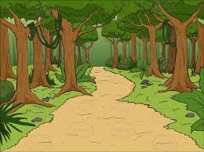**Trips to the Woods**We will require parent helpers for our trips to the woods. If you are available to help on any of the dates please fill in and return the attached slip - the more the merrier. I will then confirm who is coming with us each week by issuing a timetable for the 3 visits. All children will require appropriate clothing (wellies or boots and a waterproof jacket).

**Literacy and Maths**The children will have daily Literacy and Maths lessons and will cover the following each week:

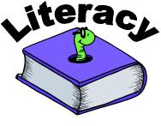**Literacy**

* **Handwriting –** focus on forming our letters correctly and neatly
* **Spelling –** variety of spelling activities daily
* **Reading and Comprehension -** three times a week
* **Writing –** imaginative and personal recount pieces

**Maths**

* **Mental Maths –** daily to develop mental agility
* **Addition and Subtraction –** covering various strategies to add and subtract

**PE**The children will have two PE sessions a week. Please ensure that your child has a full PE kit every day in case we have an additional PE slot. Please ensure all items of clothing are named to avoid confusion over ownership.

**Water and Snack**

We encourage the children to bring water bottles to school so that they can drink water during the day. To encourage healthy eating, the school's Golden Carrot competition continues. Children are encouraged to bring a healthy snack Monday to Thursday and to leave Friday as a treat day! Please refrain from giving your child peanut and nut based snacks as there are children with severe nut allergies in school.

****  
**Dates for Your Diary**

* Friday 1st September – Open afternoon – 1.45pm-2.45pm
* Thursday 28th September – Parents’ Evening – details and times to follow
* Tuesday 3rd October - Parents’ Twilight – details and times to follow
* Friday 13th of October – End of Term

We have made a very good start to P3 and I look forward to sharing our learning experiences with you over the year!

Miss Ritchie

31.08.16

