na00862_

**Term 4**

**Primary 4A Newsletter ☺**

Dear Parents/Guardians,

Three terms down… One to go! This year has flown past and I cannot believe we are in the last term already! As always we have a busy term ahead before the summer break.

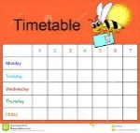**Timetable**  
The term schedule regarding specialists, library and PE slots is currently planned as follows:   
Monday **-** PE with class teacher, ICT with Mr Wilson and Library every second week ( 24.04.17, 08.05.17, 22.05.17 and 19.06.17)  
Tuesday – Science with Mrs Murray  
Friday – Assembly, PE with class teacher and Excellence Time

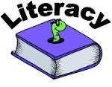**Literacy**This term in Literacy we will:

* Continue to have a daily focus on spelling, reading, comprehension and grammar.
* Focus on three different genres of writing: narrative, persuasive and instructional.
* Continue to develop our listening and talking skills through various activities.

**Maths**  
This term in Maths we will focus on:

* Revisiting telling the time within 5 minute intervals and converting between digital, analogue and 24 hour time.
* Learning about fractions and how to find one or more equal parts of an object e.g. one third, two thirds, etc.
* How to estimate, measure and order weight using grams and kilograms.
* Measure the volume and capacity of an object using litres.
* Continue learning and developing mental strategies for adding, subtracting, multiplying and dividing.

**Homework**Our homework routine will change slightly in Term 4. Homework will usually be distributed on a Friday and is to be handed in on or before the following Thursday.

**PE**The children will continue to have two PE sessions a week (Monday and Friday). We will be working on developing our fitness through various athletic activities to give us plenty of practice for Sports Day! Please continue to ensure that your child has a full PE kit every day.

**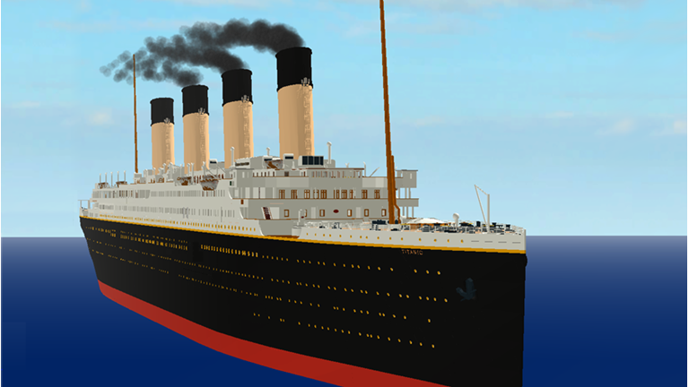Topic** Our topic this term is Titanic. The key areas we aim to cover are:

* Exploring floating and sinking, explaining why small objects like 5p sink when huge ships float
* Comparing modes of transport
* Creating a timeline of technological developments between 1912 and the present
* Comparing the rights of a first class passenger with the rights of a third class passenger
* Exploring the roles of the staff on the Titanic
* Identifying Titanic’s route on a map and roughly pinpoint the wreck of the Titanic

Everyone has shown a keen interest for the topic already and there are plenty of questions they would like answered!

**Dates for you Diary**

Parent Twilight and Parents Evening – Tuesday 25th and Thursday 27th April

May Day holiday - Monday 1st May

Learning Showcase – Friday 19th May

Occasional Day (no school) – Monday 5th June

Sports Day– Friday 9th June

Alternate Sports Day and PTA Disco – Friday 16th June

I would like to thank you again for your continued support. Please do not hesitate to contact me via your child’s home/school diary if you have any concerns or questions.  
  
Miss Ritchie