na00862_

**Term 4**

**Primary 4B Newsletter ☺**

Dear Parents/Guardians,

The last 3 terms have passed in a flash and I cannot believe we are in the last term already! As always we have a busy term ahead before the summer break.

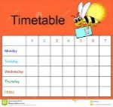**Timetable**  
The term schedule regarding specialists, library and PE slots is currently planned as follows:   
Monday **–** P.E. with class teacher and library every second week (24.4.17, 8.5.17, 22.5.17, 19.6.17)  
Tuesday – Science with Mrs Murray

Thursday – Music with Mrs Minto, P.E. with class teacher  
Friday – Assembly and Excellence Time

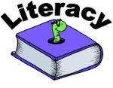**Literacy**This term in Literacy we will:

* Continue to have a daily focus on spelling, reading, comprehension and grammar.
* Focus on three different genres of writing: narrative, persuasive and instructional.
* Continue to develop our listening and talking skills through various activities.

**Maths**  
This term in Maths we will focus on:

* Learning about fractions and how to find one or more equal parts of an object e.g. one third, two thirds, etc.
* How to estimate, measure and order weight using grams and kilograms.
* Measure the volume and capacity of an object using litres.
* How to accurately measure length using millimetres, centimetres and metres, and convert between units of measure.
* Continue learning and developing mental strategies for adding, subtracting, multiplying and dividing.

**Homework**Our homework routine will change slightly in Term 4. Homework will usually be distributed on a Friday and is to be handed in on or before the following Thursday.

**PE**The children will continue to have two PE sessions a week (Monday and Thursday). We will be working on improving our basketball skills and team working skills. We will also work on our fitness through various athletic activities to give us plenty of practice for Sports Day! Please continue to ensure that your child has a full PE kit every day.

**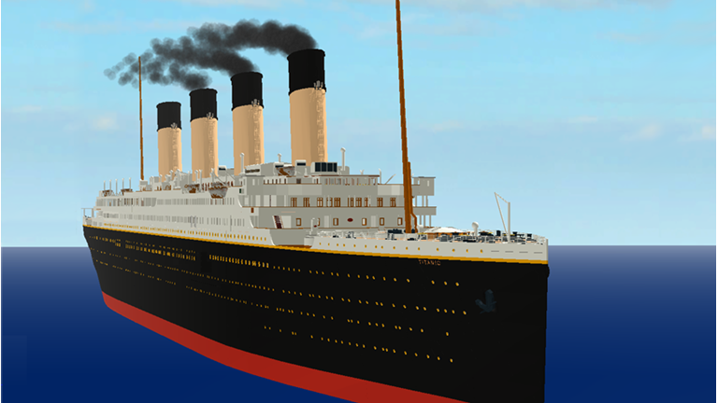Topic** Our topic this term is Titanic. The key areas we aim to cover are:

* Exploring floating and sinking, explaining why small objects like 5p sink when huge ships float
* Comparing modes of transport
* Creating a timeline of technological developments between 1912 and the present
* Comparing the rights of a first class passenger with the rights of a third class passenger
* Exploring the roles of the staff on the Titanic
* Identifying Titanic’s route on a map and roughly pinpoint the wreck of the Titanic

Everyone has shown a keen interest for the topic already and there are plenty of questions they would like answered!

**Dates for you Diary**

Parent Twilight and Parents Evening – Tuesday 25th and Thursday 27th April

May Day holiday - Monday 1st May

Learning Showcase – Friday 19th May

Occasional Day (no school) – Monday 5th June

Sports Day– Friday 9th June

Alternate Sports Day and PTA Disco – Friday 16th June

I would like to thank you again for your continued support. Please do not hesitate to contact me via your child’s home/school diary if you have any concerns or questions.  
  
Miss Mitchell