na00862_

**Term 4**

**Primary 4D Newsletter ☺**

Dear Parents/Guardians,

Three terms down… One to go! This year has flown past and I cannot believe we are in the last term already! As always we have a busy term ahead before the summer break.

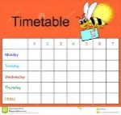**Timetable**  
The term schedule regarding specialists, library and PE slots is currently planned as follows:   
Tuesday – P.E with Mrs K.Armstrong

Wednesday – Science with Mrs Murray and library every second week (from the 26. 04. 17).

Thursday –P.E. with class teacher

**Literacy**This term in Literacy we will:

* Continue to have a daily focus on spelling, reading, comprehension and grammar.
* Focus on different genres of writing including: narrative, persuasive and instructional.
* Continue to develop our listening and talking skills through various activities.

**Maths**  
This term in Maths we will focus on:

* Learning about fractions and how to find one or more equal parts of an object e.g. one third, two thirds, etc.
* How to estimate, measure and order weight using grams and kilograms.
* Measure the volume and capacity of an object using litres.
* How to accurately measure length using millimetres, centimetres and metres.
* Continue learning and developing mental strategies for adding, subtracting, multiplying and dividing.

**Homework**Our homework routine will continue in Term 4. Homework will usually be distributed on a Thursday and is to be handed in on or before the following Tuesday.

**PE**The children will continue to have two PE sessions a week (Tuesday and Thursday). We will be working on improving our striking, fielding and athletics skills. Please continue to ensure that your child has a full PE kit every day.

**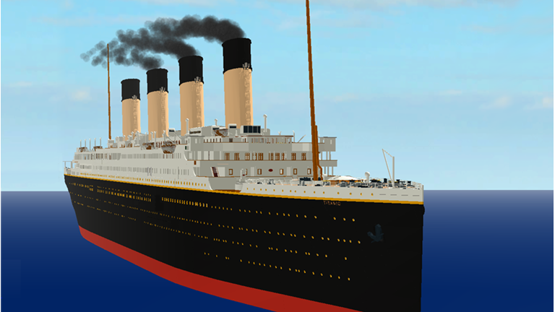Topic** Our topic this term is Titanic. The key areas we aim to cover are:

* Exploring floating and sinking, explaining why small objects like 5p sink when huge ships float
* Creating a timeline of technological developments between 1912 and the present
* Comparing the rights of a first class passenger with the rights of a third class passenger
* Exploring the roles of the staff on the Titanic
* Identifying Titanic’s route on a map and roughly pinpoint the wreck of the Titanic

Everyone has shown a keen interest for the topic already and there are plenty of questions they would like answered!

**Dates for you Diary**

May Day holiday - Monday 1st May

Learning Showcase – Friday 19th May

Occasional Day (no school) – Monday 5th June

Sports Day– Friday 9th June

Alternate Sports Day and PTA Disco – Friday 16th June

**I would like to thank you again for your continued support. Please do not hesitate to contact me via your child’s home/school diary if you have any concerns or questions.  
  
Mrs Armstrong**