P4P Newsletter

Dear Parents/Guardians,

My name is Miss Mhairi Leat and I will be your child’s class teacher. I am delighted to be working with your child and look forward to sharing their work and development with you as they progress through this year at Kintore Primary School.

**Timetable**

Our specialist times this term are as follows:

Monday – **P.E** with Miss Lewis

Tuesday – **I.C.T** with Mr Wilson and Drama with Mrs McGillivray

Thursday – P.E with Miss Leat

Friday - Library

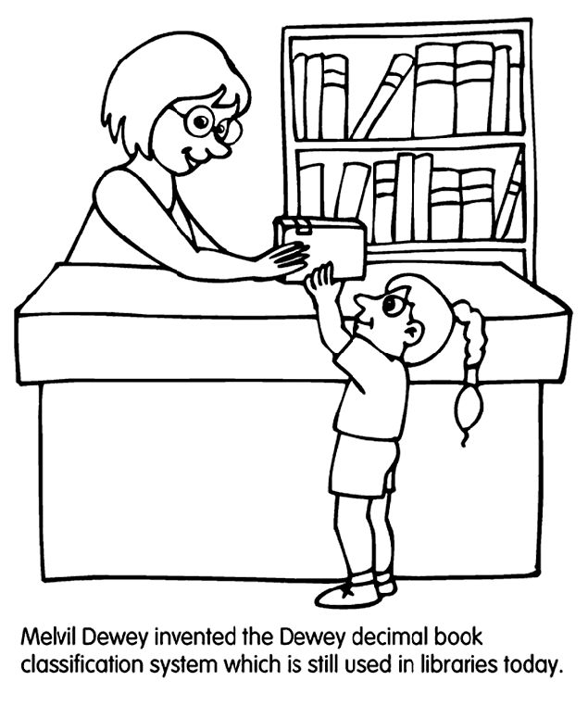**Library**

The class will visit the library every second **Friday** of this term.

Dates are as follows: 25th August, 8th September, 22nd September and 6th October.

Please check return date stamps in books to ensure books are returned in time.

**Homework and Reading**

Homework will be handed out on **Monday** to be completed and handed in on the **Friday**. Activities will cover a variety of curricular areas and reinforce learning that is taking place in class. Reading times will be shown in your child’s reading record, please remind your child to bring this every day.

**Equipment**

It was great to see so many children bringing their gym kits last Tuesday and I plan to keep these in class and send them home at the end of each term to be washed. Please ensure that long hair is tied back and that earrings are removed or covered with tape for safety during P.E. A well-equipped pencil case is useful in class. This would include sharp pencils for writing and colouring, a rubber, a ruler and a sharpener. It is also a good idea to provide an apron or adult-sized t-shirt to protect uniforms during Art lessons.

**Clothing**

Please could you ensure that all clothing is clearly labelled. Thank you.

**Water bottles and snack**

As in previous years, we encourage the children to bring water bottles (with their name on) to school so that they can drink water during the day. Please remind your child to take their bottle home at the end of the day so that they can be washed for the next day. We have some children with nut allergies in the school. Please encourage your child to take in snacks that are not nut based. Thank you.

[](https://www.bing.com/images/search?q=literacy+&view=detailv2&&id=E617497F80E1DC025D86419158474F7221396F8E&selectedIndex=6&ccid=OmpayYbk&simid=608011274044834255&thid=OIP.M3a6a5ac986e448f08dc62d6e768c78dao0)**Literacy**

This term in Literacy we will:

* Writing our own myths and legends stories which link to our topic on Scotland.

*Having explored the elements which writers use in different genres, I can use what I learn to create my own stories, poems and plays with interesting structures, characters and/or settings.* ***ENG 1-31a***

* Develop our listening skills through a variety of activities including the use of audio books and our class novel – ‘How to Train Your Dragon.’

*I can show my understanding of what I listen to or watch by responding to and asking different kinds of questions.* ***LIT 1-07a***

**Maths**

This term in Maths we will focus on:

* Developing and sharing mental strategies for adding, subtracting, multiplying and dividing up to three digits.
* Written methods of addition and subtraction within 10,000.

*I can use addition, subtraction, multiplication and division when solving problems, making best use of the mental strategies and written skills I have developed.* ***MNU 1-03a***

* Describing, following and recording routes and journeys using signs, words and angles associated with direction.

*I can describe, follow and record routes and journeys using signs, words and angles associated with direction and turning.* ***MTH 1-17a***

**Term 1 Topic**

Our topic this term is Scotland. We will be broadening our knowledge of Scotland’s main cities, rivers and lochs.

*I can describe and recreate the characteristics of my local environment by exploring the features of the landscape.* ***SOC 1-07a***

We will also be looking at the different types of food produced both locally and across Scotland.

*Having explored the variety of foods produced in Scotland, I can discuss the importance of different types of agriculture in the production of these foods.* ***SOC 1-09a***

**Dates for your Diary:**

* 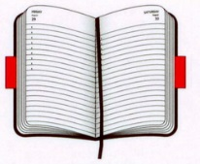Friday 1st September – Open Afternoon
* Monday 11th September – Scottish Maths Week
* Thursday 28th September - Parents’ Night
* Tuesday 3rd October – Parent Twilight

Please always feel free to get in touch with me at school if you have any queries or concerns. I look forward to meeting you soon and working together to support your child.

Thank you

Miss Leat