

Primary 7K

Term 1 Newsletter

Welcome back and welcome to P7K! I hope that you all had a restful and fun-filled summer. I have really enjoyed hearing what the children have been up to. Everyone has settled in well and are ready for a successful, challenging and enjoyable school year. Below you will find important dates for your diary, our class timetable and an outline of some of the things we will be learning. If you have any questions please do not hesitate to write in your child’s diary, contact the school office or catch me at the end of the day.

Many thanks,

Miss Nicola Seivwright

**Homework / Reading**

Homework will be issued each week on a Thursday to be completed and returned by the following Tuesday. Activities will cover a variety of curricular areas and reinforce learning that is taking place in class. Can all homework tasks please be signed by an adult and I also welcome any comments that you wish to write in your child’s homework jotter. I intend to post homework tasks on a class Glow site each week. This will be where the children will access their task and will have the opportunity to use the chat tool to ask questions which may be answered by myself or classmates. This will be monitored at all times to ensure it is being used appropriately. Can you please check that Glow can be accessed at home, if this is not possible alternative arrangements can be made.

Each child has a Reading Record which will show you what they are to read at home and when it should be read by. I would encourage your child to discuss the text with an adult to show their understanding. Additionally, they could read more on a topic, or similar books by the same author. Again, please sign their diaries to show they have completed their reading. In class, we will use our reading books for activities on a daily basis, so please encourage your child to bring their book and reading record with them every day.

**In class**

* 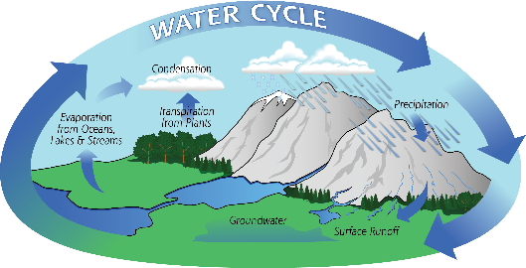We will start off the term with two mini-topics, before and after our trip to Inverclyde. Through discussion with the children, we will plan our next topics to ensure we are offering personalisation and choice, taking the interests of the children in to consideration.

*I can apply my knowledge of how water changes state to help me understand the processes involved in the water cycle in nature over time. SCN 2-05a*

*Through exploring non-renewable energy sources, I can describe how they are used in Scotland today and express an informed view on the implications for their future use.*

*SCN 2-04b*

* In Maths this term we will be starting with some assessments and revising several areas of numeracy including addition, subtraction, multiplication and division.
* In Literacy we will be learning more about writing poetry and recounts. There will be some cross curricular links as we carry out research and experiments for our topic.

*‘By considering the type of text I am creating, I can select ideas and relevant information, organise these in an appropriate way for my purpose and use suitable vocabulary for my audience - LIT 2-26a’*

**Dates for your Diary**



* Open Afternoon – Friday 1st of September (1.45pm – 2.45pm)
* Inverclyde Trip – Monday 4th September – Friday 8th September
* School photos - Thursday 21st/ Friday 22nd September
* P7K Café - Tuesday 26th September (9.15am – 10.00am)
* PTA Quiz Night – Friday 29th September
* Parents Night – Thursday 28th September
* Parents Twilight – Tuesday 3rd October
* October Holiday – Monday 16th October – Friday 27th October

**Timetable**

Science – Wednesday with Mrs Murray

Modern Languages – Wednesday with Frau Kaup

Library – every second Tuesday (beginning 29th August)

P.E. – Monday & Thursday – P.E. kits should be in school at all times and taken home regularly to be washed.

-----------------------------------------------------------------------------------------------------

I can attend the P7K Cafe on Tuesday 26th of September

Number of people attending: _____

Child’s Name:________________________

Signed:____________________________