**P6K News**

**August 2017**

**Homework** will go out on a Thursday to be returned on a Tuesday.

There will be a literacy and numeracy task each week plus another area of the curriculum. These will be a mixture of pre-learning, applying learning and revision.

If there are any difficulties with homework please don’t struggle over it; just send a note in so we can discuss it.

**Topics**

In preparation for our assembly, we will be exploring Kintore’s Aims and Values and what they mean and how they apply to us.

**All About Me**: We will learn about what makes us unique, recognising our individual strengths and abilities and how we can share these with others.

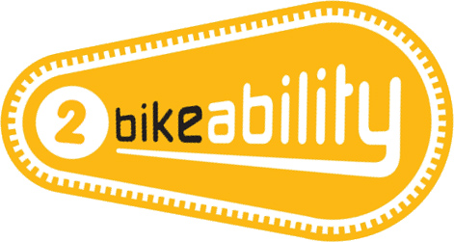**Bikeability:** Developing skills for cycling safely on roads. To build on this further we will build understanding of how a bike works and how to navigate using OS maps.

Thank you to those parents who have already volunteered to support us with this. If you are not able to commit regularly or are unsure of your availability then you can still help at the last minute. We need all the help we can get. The more adults we have the more practice the children get.

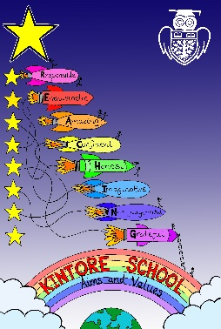

**Timetable –key events:**

Monday: PE indoors

Wednesday: German with Frau Kaup

Science with Mrs Murray

Please note that we will be aiming for PE twice a week with PE outdoors on the day with the most suitable weather.

**Welcome to P6K**

We are settling down and looking forward to a busy year with plenty of exciting, challenging activities.

You are welcome to visit us on the afternoon of Friday 1st September and to join us for our class assembly exploring the school values on the morning of Friday 15th September.

**Get in Touch** If you have any questions or concerns, please feel free to put a note in your child’s Reading Record or make an appointment to see me in person.

**Literacy**

Reading will be written in pupil’s Reading Records. Please ensure this is kept up to date and notify me of any difficulties with this. Reading books should be brought into class every day.

I would also encourage pupils to read for their own personal interest and enjoyment from a wide range of texts. This can also be recorded in their reading record.

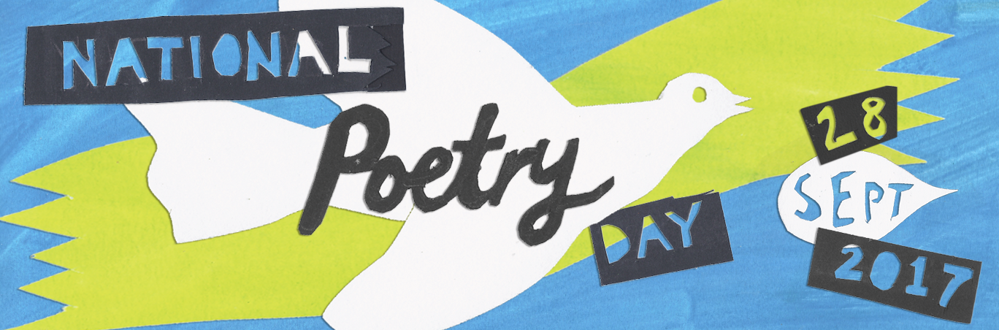Thursday 28th September is National Poetry Day. We will extend this across the week and have a focus on reading, writing and analysing poetry.

We are in the process of setting individual writing targets. This term we will be focusing on instructional writing with a link to our Bikeability work.

**Numeracy**

In numeracy we are building our confidence working with different mathematical operations with a particular focus on sharpening our mental maths abilities and explaining our calculations. We will extend our ability to add, subtract, multiply and divide to five or six digit numbers including working with decimals. We will explore different strategies including how to use rounding and estimating to check if an answer “looks right”.

In line with our topic work we will also be investigating co-ordinates and scale when using OS maps.

11th-17th September is Scottish Maths Week and we will be looking to take part in some of the activities and challenges available as part of this.



**Health and Wellbeing:**

As part of our topic work we will be looking at developing an understanding of our own values and how these impact on the way we live. We will be working on developing confidence in expressing our opinions and sharing our beliefs with others.

In PE we will be developing ball skills for striking games (such as rounders or cricket). This will include throwing, catching and aiming as well as learning how to work as a team.

Thank you for bringing in PE kits. If these are taken home to be washed please ensure they are brought back promptly (or swapped for a clean kit). We will take advantage of any fine weather for outdoor PE.

If your child has an illness or injury which may affect their ability

to take part in PE, please send in a note (in their Reading Record)

and I will consider how best they may participate whether that

is an adapted active role or as a referee or coach.

I look forward to working closely with you this year,

Mrs Flett