Assessing Writing towards the end of the Nursery Session

What are we looking for?

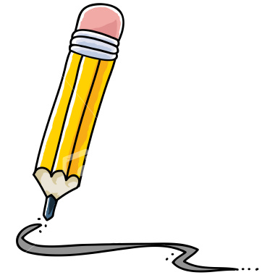
Appreciates the difference between drawing and writing
Uses wavy or zigzag marks to represent writing
Uses a series of circular and/or straight marks
Writes letters/symbols in mixed up positions on page
Knows letters are written in a line
Writes from top of page and left to right
Leaves spaces between ‘words’ when writing
Writes own name
Writes in lower case and capitals
Writes a few letters from own name

