P1P Newsletter

Term 2

A very warm welcome back after the October break. The children all seem to have enjoyed their October holidays and are refreshed and ready to learn lots of new things. It’s hard to believe that we are in to November already and will soon be learning our Christmas Songs!

**Timetable**

This term our timetable is as follows:

**Monday** – P.E. with Miss Stewart

**Wednesday** – Drama with Mrs. McGillivray

**Thursday** – Music with Mrs. Minto

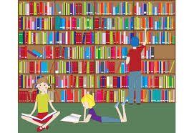**Library**

The children will visit the library every alternate **Thursday**. The dates are as follows -:

17th November, 1st December and 15th December.

Please ensure your child brings back their library book before the next visit either to class or the Library.

**Literacy**

The class will continue to learn the letter sounds to help them develop their reading and writing skills. We will be listening for beginning, middle and end sounds in short words. The children will be working at their own pace and revising any sounds they have not retained.

In writing we will be encouraging the children to write letter sounds they can hear in words to help them write simple sentences independently. We will also encourage pupils to leave ‘finger spaces’ between words and end their sentences with a ‘full stop’.

**Numeracy**

[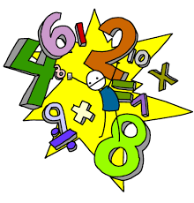](http://www.google.co.uk/url?sa=i&rct=j&q=&esrc=s&frm=1&source=images&cd=&cad=rja&uact=8&ved=0CAcQjRxqFQoTCO2s_vPw9sgCFcK0GgodQ_oMag&url=http://www.westgate.lincs.sch.uk/page/?pid=48&psig=AFQjCNHue_un8qAqi7-MKhjdkJbohYodcw&ust=1446730385302337)We will be using lots of mathematical language (e.g. before, after, in-between) and we will be practising our mental maths, e.g. number facts to 10, one more, two more, etc. The children will continue to work on addition to 10 and we will be making sure all number formations are correct. We will be using analogue clocks to look at ‘o’clock times and learn how to make and record information with different charts. We will also be looking at the seasons and the days of the week.

**Health & Well-Being**

****Our main focus will be developing friendships in the class and playground. The class will have a weekly P.E. session with the class teacher and this term we will be focussing on Gymnastics.

**Social Studies**

This term our topic is ‘Our Community’. We will be going on walks around the town and will invite visitors to talk to us about their jobs in the community.

**Homework**

Letter sounds will continue to be handed out on a Wednesday to be returned the following Monday and Homework will be handed out on a Thursday to be returned the following Wednesday. Tasks will be carefully planned and differentiated to support the work taking place in class.

**Things to remember**

Children should:

* bring their book bag and home/school notebook to school **every day** (please ensure that this is checked daily for notes or letters)
* have **sharp** writing and colouring pencils every day
* Bring appropriate items of clothing for all weather conditions – we will be outside in all weathers! If your child is wearing wellies please also give them a pair of shoes to change into.

Please ensure that **all** pencil cases, bags and items of clothing (including gym kit and shoes) are clearly labelled.

**Important Dates**

* **Thursday 17th November** – P1P’s Walk to Hallforest Castle
* **Friday 9th December** - P1’s Christmas Singalong
* **Monday 19th December** – P1’s Christmas Party
* **Wednesday 21st December** – Church Service

This term will be busy but should be lots of fun in the lead up to Christmas.

Thank you for your support

Miss Stewart