
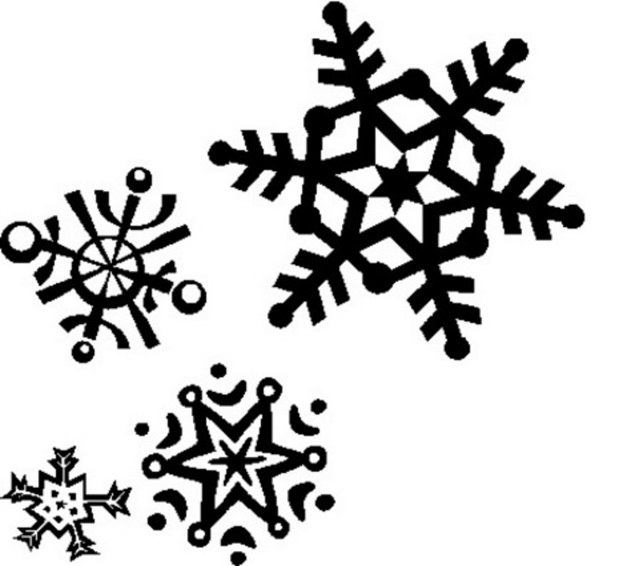
Primary 2K
Term 2 Newsletter

Welcome back to P2K!
I trust you all had a restful break and are ready for the busy term ahead.

Our Teachers  This term the teachers helping us with our learning throughout the week are.  Tuesday: Drama with Mrs MacGillivray  Thursday: Music with Ms Minto  These sessions will focus mainly on rehearsals for our Nativity in December. | Dates for Diary  Monday 13th & Tuesday 14th November: In-service days  Thursday 14th December: Nativity Performance  Wednesday 20th December: Christmas Party  Friday 22nd December: Last day of term
Weekly Routines
Monday and Thursday: PE
Wednesday: Homework returned.
Thursday: Homework is given out.
Library visits – These will be on a Thursday 9th & 23rd November and 7th & 21st December.

Our class learning

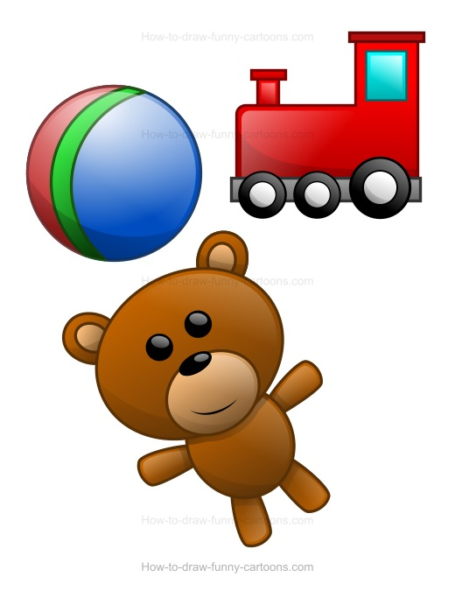
Class Project - Toys
By investigating forces of toys and other objects, I can predict the effect on the shape or motion of object. SCN 1-07a
Through exploring properties and sources of materials. I can choose appropriate materials to solve practical challenges. SCN 1-15a

This term we will be learning about how forces and friction work to make toys move through different experiments. We will also be exploring the properties of materials and why certain toys are made from different materials such as wood, plastic, or metal. We will also be investigating more complex properties including magnetism. We will be making comparisons between toys of the past and the present. I am sure the class will share with about our class Elf. ☺


Literacy
I can convey information or describe events and processes in different ways. LIT 1-28a
I am learning to select and use strategies and resources before I read, and as I read, to help make the meaning of texts clear. LIT 1-13a

Reading homework will continue to be given every week with a focus on understanding the words, facts and stories that we read. We will be looking at the concept of writing letters and this will link with our topic. There will be a focus on developing our writing and using connectives to help us.

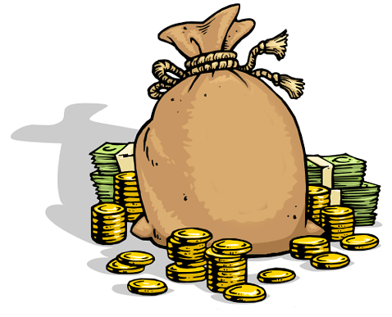
Maths – Number and Money
I can use money to pay for items and can work out how much change I should receive. MNU 1-09a
I have explored symmetry in my own and the wider environment and can create and recognise symmetrical pictures, patterns and shapes. MTH 1-19a

Alongside continuing our learning in number we will also be learning about money this term and applying it within the context of Toys and we will be having a classroom toy shop. We will also be looking at symmetry and making symmetrical patterns and pictures. In class we will also look at finding lines of symmetry within shapes. At home it would be helpful for you to go over number bonds with your child.

Nativity
Once parts are decided words will be sent home to those children with a speaking part. This will allow them extra time to learn their parts.

Outdoor/Daily Mile
Although the weather will most likely be changeable this term we will endeavour to do our Daily Mile as much as possible. As a general rule, if pupils have had an outdoor break/lunch we will try to complete our Daily Mile.

Water bottles and snack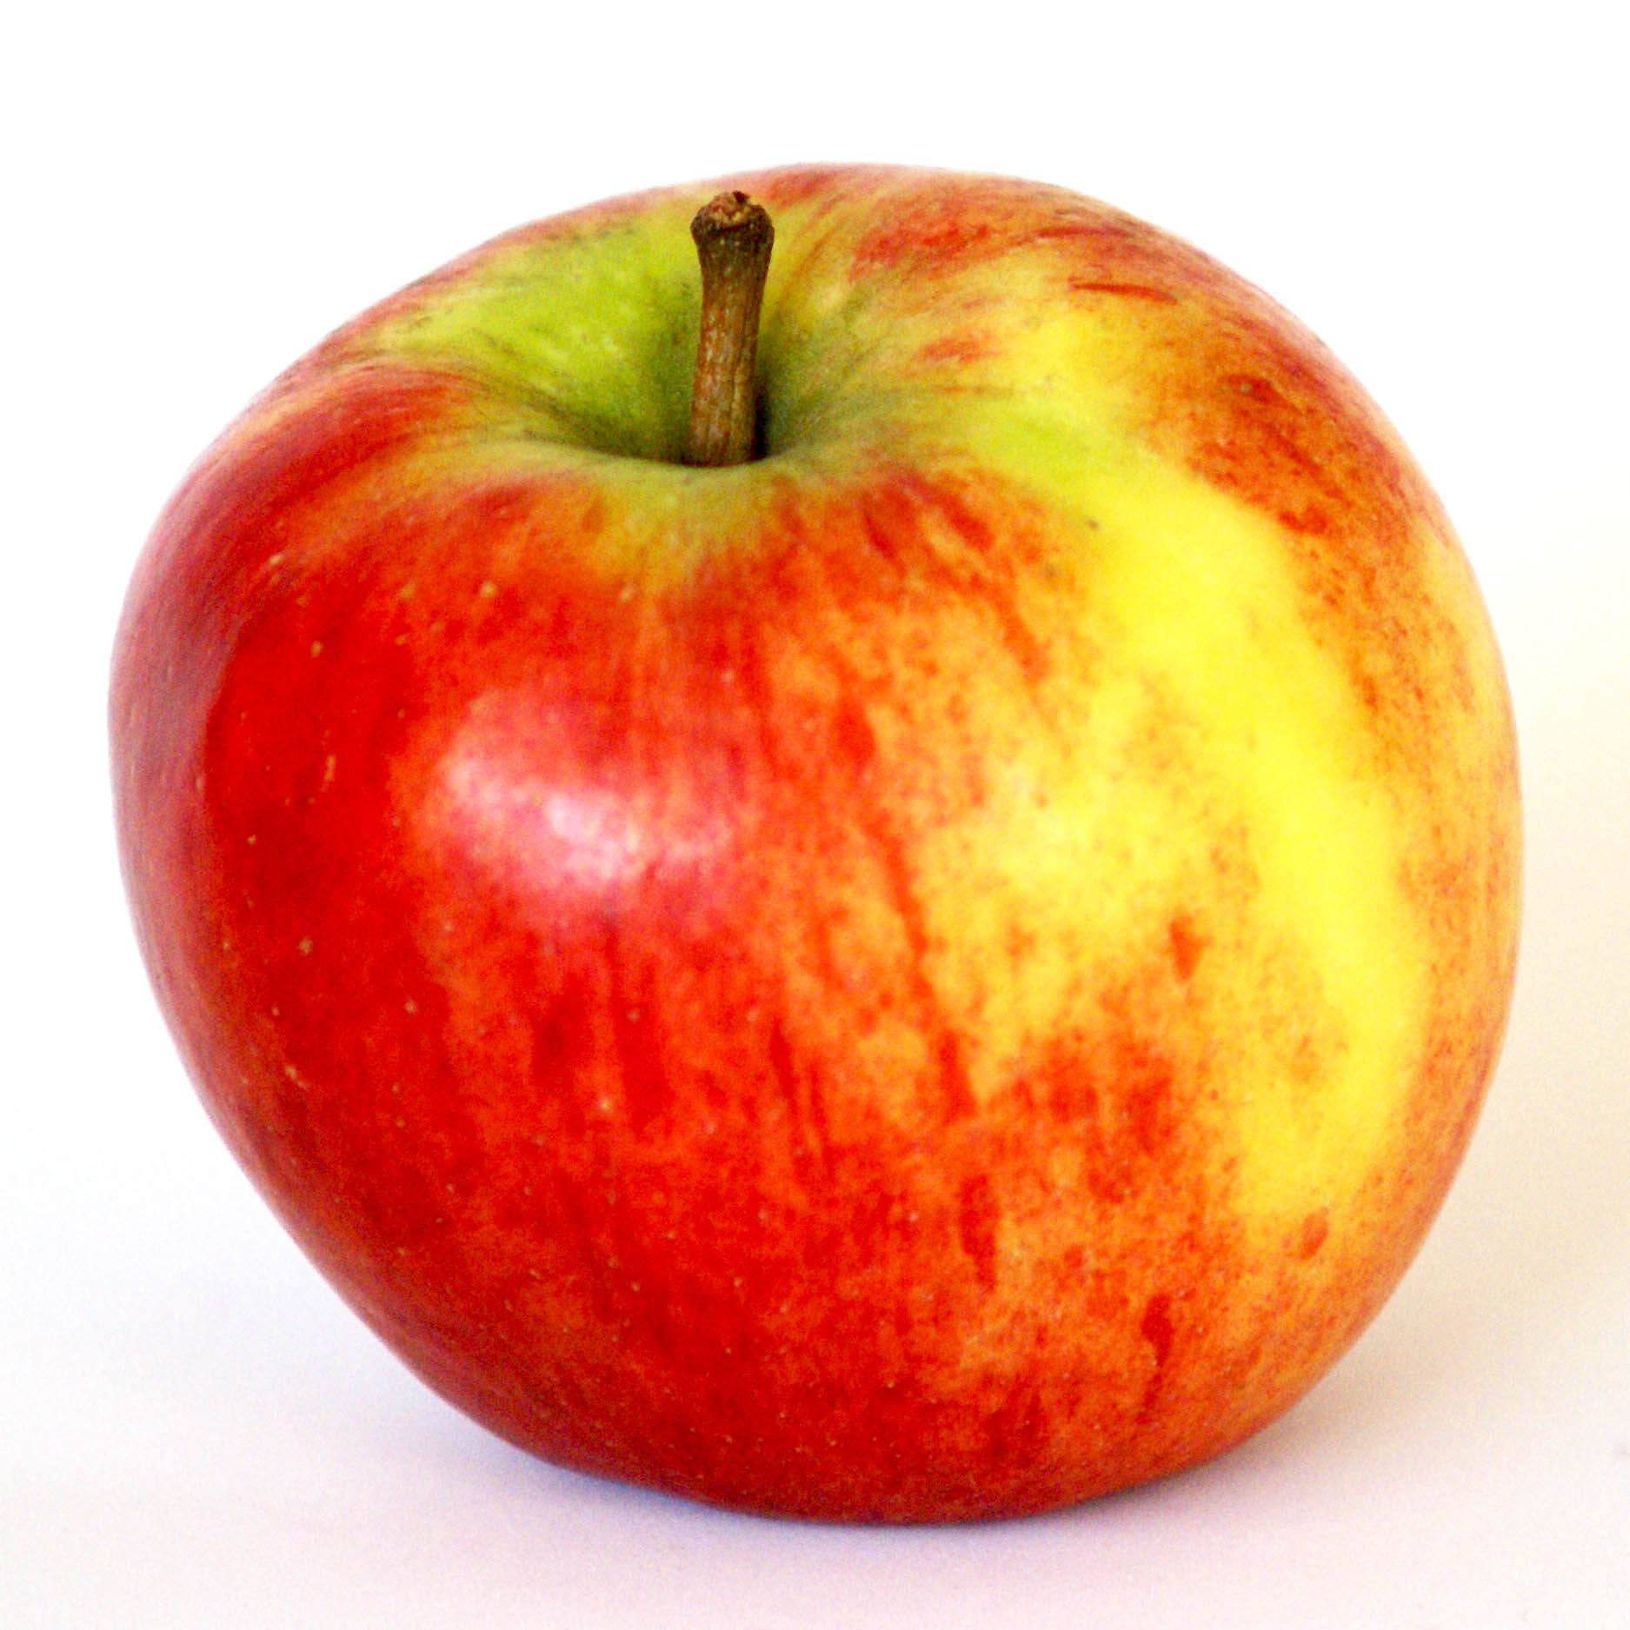
As always remember to send in named water bottles daily so children can have a water break.
Healthy snack is still encouraged and we have been lucky to win the Golden Carrot certificate twice last term. Keep up with the Healthy snacks Monday – Thursday.

As always, should you wish to discuss anything at all with me please, please do not hesitate to get in touch through the school office or through your child’s home/school diary.

Thank you for your continued support,
Mrs Russell

