
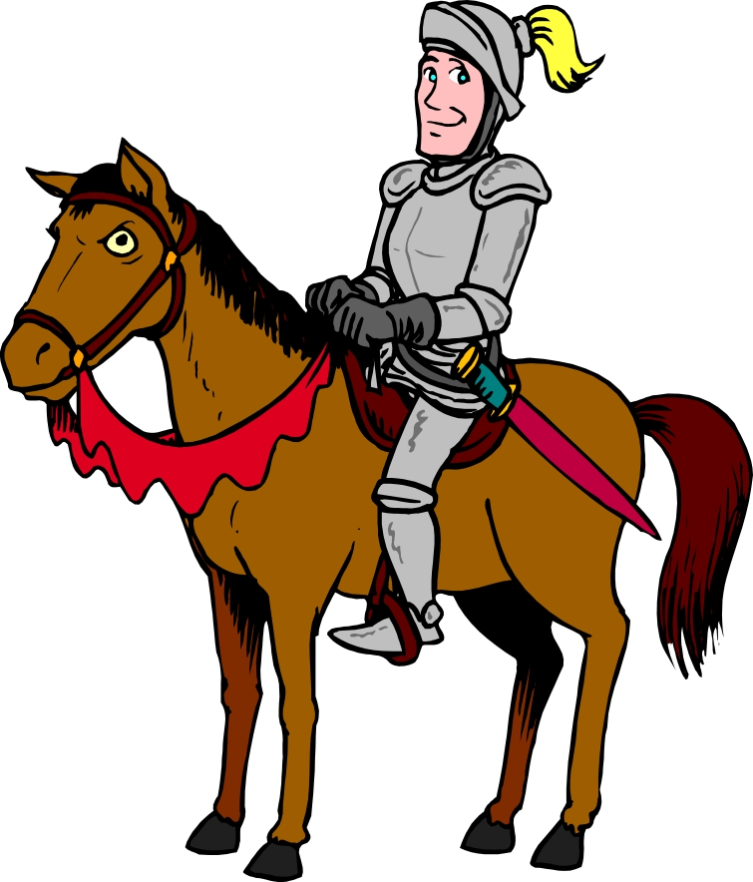
Primary 2S
Term 4 Newsletter

Welcome to the fourth, and final, term of Primary 2. I hope everyone had a fun and restful Easter break. As always, term 4 is shaping up to be a busy one and our class has many exciting things to look forward, including our Assembly very soon!

Our Teachers  This term we have two other teachers helping us with our learning throughout each week.  Tuesday: Drama with Mrs MacGillvary  Wednesday: R.M.E & Problem Solving with Mrs Donelly | Dates for Diary  Thurs 26th April: Parent Evening  Tues 1st May: Parent Twilight  Fri 4th May: Class Assembly  Mon 7th May: May-day Holiday  Mon 4th June: Local Holiday  Fri 8th June: Sports Day (alternate on 15th)  Fri 6th July: Last day of term 4
Weekly Routines
Monday: Library – we had our first visit on Monday the 23rd, so our next visit will be on the
……………………………. 7th of May and every second week following.
Wednesday: Homework returned
Thursday: Homework out


Class Project – History of our Local Area (Castles)
I can compare aspects of people’s daily lives in the past with my own by using historical evidence or the experience of recreating an historical setting. SOC 1-14a

This term we will be developing an understanding of the world by comparing how people live today and in the past. Our learning will focus on the local area, including looking at how our town has changed and visits to historical sites such as Hallforest Castle. An important element of this topic will be developing a sense of chronology – the order in which things have happened in the past. This will start with our own history e.g. life timeline from birth, and develop into a larger timescale.

Physical Education
This term I hope to take our P.E. lessons outside more often. As always, this will be weather dependant – but even the nicest day can still be colder than indoors. Pupils will bring their kits home to check what they have is suitable for this. For example, you may feel joggers or leggings would be more appropriate than shorts. If you feel what they have is fine please just return kits as they are.

As always, should you wish to discuss anything at all with me please, please do not hesitate to get in touch through the school office or through your child’s home/school diary.

Thank you for your support,
Mrs Morrison & Primary 2S

