
P3K Newsletter
Term 4

Dear Parents

A warm welcome back to the new term! I hope you all had a lovely Easter holiday.

Our Timetable
Our timetable for term 3 is as follows:
Thursday P.E. with Ms Macdonald and Library every fortnight


Library
The class will visit the library every second Thursday. Our first visit will be on Thursday 26th April. Future dates are as follows: 10th May, 24th May, 7th June, 21st June and 5th July. Please continue to ensure your child takes their library books back prior to their next visit.

Homework
Our homework routine continues as before with homework being issued on a Wednesday, to be completed and returned for the following Tuesday. As always, if you have any comments or concerns, please let me know by writing a note in the Reading Record book.

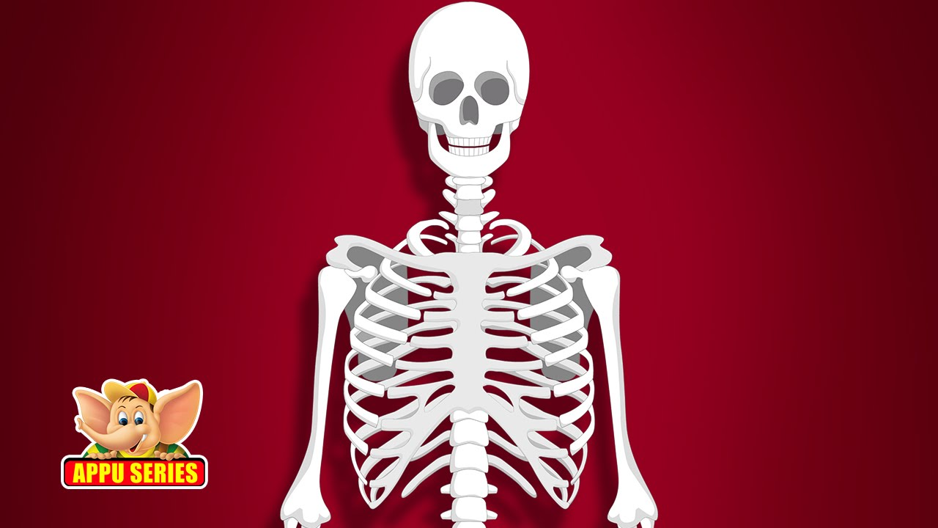
Topic
This term our topic is Our Healthy Body. Our focus will be on building our knowledge of the body and what we need to do to keep safe and healthy. As part of this we will be promoting a healthy lifestyle and the use of the outdoors for health and wellbeing. This topic will also incorporate an aspect of our Sexual Health and Relationships Education where we will be looking at the changes our bodies go through as we grow. More information about this is to follow and you will have the opportunity to view the resources if you wish. In Primary School children learn about the world of work. If you are in a health related profession and would like to talk to the children about what you do we would be delighted to hear from you. This gives the children the valuable opportunity to discuss skills development and make the link between learning in school and the world of work.
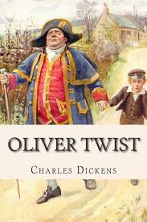
Events
We look forward to a visit from a Theatre Group on the 28th May. They
will be performing their version of the classic story of ‘Oliver Twist’ by
Charles Dickens.

Targets

This term in Listening and Talking the children will be learning to select appropriate topic vocabulary in discussion, to make notes as they watch and listen and to use information they have gathered to write.
In Reading we will continue with our Reading Champions where the children will be recommending texts they have enjoyed to others. They will be encouraged to ask questions about a topic and to scan texts for the information they need.

In Writing we will continue to experiment with a range of poetic techniques such as rhyme, repetition, or similes and to give clear descriptions using adjectives. We will also be learning how to continue a story. The children will be encouraged to check their work regularly to make sure it makes sense and to edit for improvement.
In Maths the children will be learning to solve missing number problems using their knowledge of number facts. We will also be focusing on measurement and the children have already had fun measuring their bones!
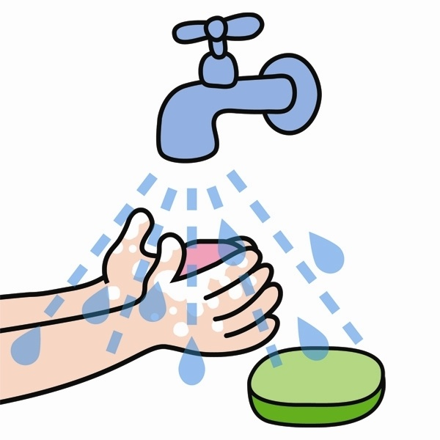
In Health and Well Being we will be focusing on health and hygiene linked to our topic Our Healthy Body. We will be learning the importance of consistently and independently demonstrating personal hygiene practices. We will also be exploring the different services and facilities within the local community. In P.E. we will be focusing on aerobic activities and will be learning striking and fielding skills and games.

Dates for your diary
- Local Holiday Monday 7th May
- Theatre Group Monday 28th May
- Local Holiday Monday 4th June
- Sports’ Day Friday 8th June
- PTA Disco Friday 15th June
- End of term Friday 6th July

I look forward to continuing our partnership in your child’s education. If you would like more information or there is anything you would like to discuss please do not hesitate to contact me.

Yours sincerely

Ms Macdonald

