na00862_

**Term 2**

**Primary 4A Newsletter ☺**

Dear Parents/Guardians,

I can’t quite believe how fast Term 1 flew past, and we are definitely well underway with Term 2 already! Everyone has settled quickly back into class and we all enjoyed sharing our stories from the October holidays. It was excellent to see so many of you at Parents’ Evening last term and I look forward to working closely with you to ensure that your child has another productive and enjoyable term.

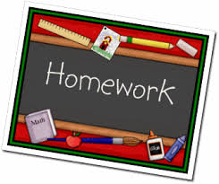**Homework**Our homework routine will continue in Term 2. Homework will be distributed on a Thursday and is to be handed in on or before the following Tuesday. This will consist of Literacy, Numeracy and one Topic task each week. Reading homework will be given out at least three times a week.

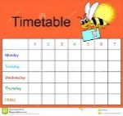**Timetable**  
This term P4A are very fortunate in that they will continue to benefit from exciting learning experiences in class and with our visiting specialists. Please note that timings and specialists are likely to change each term. This is to ensure your child has a rounded experience of the curriculum. The current schedule is as follows:

Monday**-** Library every first week (7.11.16, 21.11.16, 5.12.16, 19.12.16) ICT with Mr Wilson   
Tuesday- PE with Mrs Armstrong  
Thursday-PE with class teacher, Kodaly with Mrs OkumuFriday- Assembly and Excellence Time

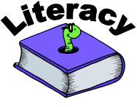**Literacy and Maths**The children will continue to have daily Literacy and Maths lessons and will cover the following each week:

**Literacy**

* Handwriting **–** focus on neat and joined up handwriting
* Spelling **–** variety of spelling activities daily
* Grammar **–** question marks, exclamation marks, speech marks and paragraphs
* Reading and Comprehension **-** three times a week
* Writing **–** narrative writing focusing on developing our character and setting descriptions

**Maths**

* Mental Maths **–** daily to develop mental agility
* Addition and Subtraction **–**  learning and developing formal written methods
* Multiplication and Division **–** learning and revising the 1-10 times tables and linking mulplication with division

**Topic**This term our topic is all about ‘Water.’ We are planning to cover:

* The water cycle
* Water usage
* Mapping skills – identifying water sources in and around Scotland
* Global Awareness - comparing our water usage with a third world country
* Importance of clean water
* Consequences of using too much water
* Water changing form; melting, freezing and boiling

**Dates for your Diary**

**P4A Assembly -** Friday 11th November  
  
**In-service Days** - Monday 14th and Tuesday 15th November the children will not be in school on these days  
 **Christmas Fair** – Saturday 19th November  
  
**Classwork home –** Friday 2nd December to be returned on the Monday   
  
**P4 and P5 Christmas Party** - Thursday 15th December

**Church Service/End of Term 2** - Wednesday 21st December

**Term 3 Begins** - Thursday 5th January

I would like to thank you again for your continued support. Please do not hesitate to contact me via your child’s home/school diary if you have any concerns or questions.

Miss Ritchie