na00862_

**Term 2**

**Primary 4B Newsletter ☺**

Dear Parents/Guardians,

The first 2 weeks of term 2 have been very busy for P4B with lots of changes and exciting things happening but they have settled in well and are working hard. I have enjoyed getting to know all of the children and look forward to working with them for the rest of the year. We have lots of exciting learning planned for term 2 so we are going to be kept very busy!

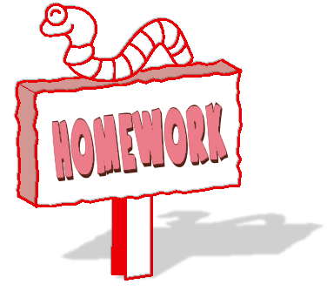**Homework**Our homework routine will continue in Term 2. Homework will be handed out on a Thursday and is to be handed in on or before the following Tuesday. This will consist of literacy, numeracy and one topic task each week. Reading homework will be given out at least three times a week.

**Timetable**  
This term P4B are very fortunate in that they will continue to benefit from exciting learning experiences in class and with our visiting specialists. Please note that timings and specialists are likely to change each term. This is to ensure your child has a rounded experience of the curriculum. The current schedule is as follows:

  
 **Tuesday** P.E. with Mrs Armstrong

**Wednesday** Science with Mrs Murray

**Thursday** Kodaly with Mrs Okumu

**Friday** Assembly and Excellence Time

**Library**

Our library slot is on a Thursday on the following dates: 12/11/16, 26/11/16 and 10/12/16.

**Literacy and Maths**The children will continue to have daily Literacy and Maths lessons and will cover the following each week:

**Literacy**

* **Handwriting –** focus on neat and joined up handwriting
* **Spelling –** variety of spelling activities daily
* **Grammar –** question marks, exclamation marks, speech marks and paragraphs
* **Reading and Comprehension -** three times a week
* **Writing –** we will be focusing on narrative pieces with a focus of developing our character and setting descriptions through concise planning and writing different genres

**Maths**

* **Mental Maths –** daily to develop mental agility
* **Addition and Subtraction –**  learning and developing formal written methods
* **Multiplication and Division –** learning and revising the 1-10 times tables linking with division

**Topic**This term our topic is all about ‘Water’ we are planning to cover:

* The water cycle
* Water usage
* Mapping skills – identifying water sources in and around Scotland
* Global Awareness- comparing our water usage with a third world country
* Importance of clean water
* Consequences of using too much water
* Water changing form; melting, freezing and boiling

**Dates for your Diary**

**In-service Days** - Monday 14th and Tuesday 15th November the children will not be in school on these days.

**P4B Assembly -** Friday 18th November

**Christmas Fair** – Saturday 19th November

**Classwork home –** Friday 2nd December to be returned on the Monday

**P4 and P5 Christmas Party** - Thursday 15th December

**Church Service/End of Term 2** - Wednesday 21st December

**Term 3 Begins** - Thursday 5th January

I would like to thank you for your support and making me feel so welcome to Kintore School. Please do not hesitate to contact me via your child’s home/school diary if you have any concerns or questions. I hope we continue to have a productive and exciting term.

Miss Mitchell