P4K Newsletter
Term 2

Dear Parents/Guardians,
Welcome back. I hope you all had an enjoyable October break. Everyone has settled back into class and they are ready for a busy Term.
Our Timetable
The class will have:
Science with Mrs Murray on Tuesdays and R.M.E. with Mrs Young on Fridays. Our P.E. session will be on a Monday. We will also be going outside for Daily Mile and when the weather gets too cold we will be developing our dance skills using the GoNoodle app.

Library
The class will visit the library every fortnight. The next three dates are as follows:
Thursday 16th November, Monday 27th November, and Monday 11th December. Please ensure your child takes their library books back prior to their next visit.

Homework & Reading
Homework will be handed out on Wednesday to be completed and handed in on the Tuesday. Activities will cover a variety of curricular areas and reinforce learning that is taking place in class. Reading times will be shown in your child’s reading record, please remind your child to bring this every day.

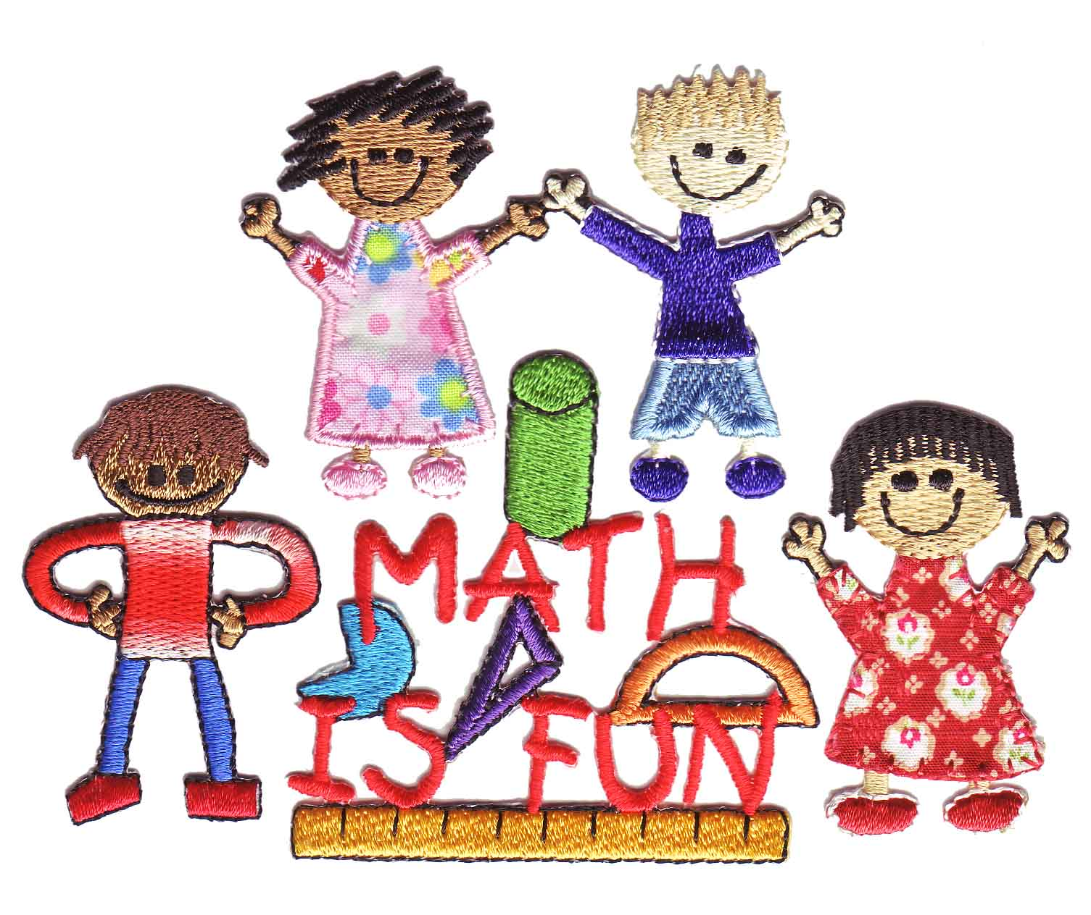
Our Class Learning
This term in Maths we will focus on:
- Continue to develop and share mental strategies for adding, subtracting, multiplying and dividing up to three digits.
- Written methods of operations within 10,000.
I can use addition, subtraction, multiplication and division when solving problems, making best use of the mental strategies and written skills I have developed. MNU 1-03a
- Use of a range of instruments to estimate and measure and record the weight, capacity, length and area of objects.
I can estimate how long or heavy an object is, or what amount it holds, using everyday things as a guide, then measure or weigh it using appropriate instruments and units. MNU 1-11a
I can estimate the area of a shape by counting squares or other methods. MNU 1-11b

Literacy
This term in Literacy we will:
- Writing our own play scripts and instructions.
Having explored the elements which writers use in different genres, I can use what I learn to create my own stories, poems and plays with interesting structures, characters and/or settings. ENG 1-31a

Social Subjects

We will continue with our Scotland topic for the first half of this term and then begin a new topic on Lego. Here we will focus on recognising 2D and 3D shapes and how they can be used to visually represent ideas and concepts. Children will have the opportunity to create manual and/or digital sketches to represent their ideas.
I can explore and experiment with sketching, manually or digitally, to represent ideas in different learning contexts. TCH 1-11a
I explore and discover engineering disciplines and can create solutions. TCH 1-12a

As always, should you wish to discuss anything at all with us please, please do not hesitate to get in touch through the school office or through your child’s home/school diary.
Mrs Bain & Mrs Cordiner

