Welcome back! I hope you all had an enjoyable festive period! The children have settled back in and are ready for a busy term ahead.

Timetable
The class will have:
P.E will be on Mondays and we will be taking part in the Daily Mile Initiative. Our aim is to ‘walk’ from Kintore to Rome – a short trip of only 1,698.5 miles!
Science with Mrs Murray on Tuesday afternoons
Music with Ms Minto on Thursdays
Art with Mrs Young on Fridays.

Library
The class will visit the library every second Thursday. The dates are as follows 18th January, 1st February, 17th February, 15th February, 1st March, 15th March and 29th March. Please ensure your child takes their library books back prior to their next visit.

Homework and Reading
This term homework will be issued on a Wednesday to be returned the following Tuesday. Activities will cover a variety of curricular areas and reinforce learning that is taking place in class. Reading times will be shown in your child’s reading record, please remember to bring this every day.

Our Class Learning

This term in Maths we will be focusing on:
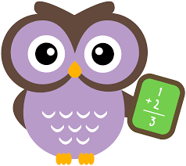
Money - I have investigated how different combinations of coins and notes can be used to pay for goods or be given in change. MNU 1-09b
Fractions linked to division - Through exploring how groups of items can be shared equally, I can find a fraction of an amount by applying my knowledge of division. MNU 1-07b
Number systems linked to our topic on the Romans - I have discussed the important part that numbers play in the world and explored a variety of systems that have been used by civilisations throughout history to record numbers. MTH 1-12a

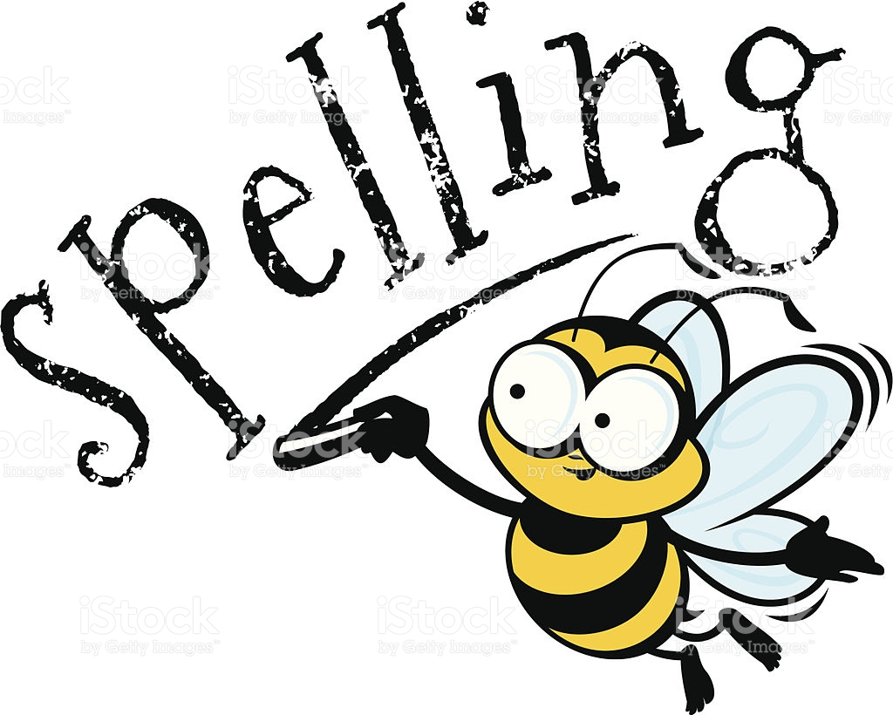
As part of our Literacy work we will:
Develop our notetaking skills - As I listen or watch, I am learning to make notes under given headings and use these to understand what I have listened to or watched and create new texts. LIT 1-05a
Extend our comprehension skills - To show my understanding, I can respond to different kinds of questions and other close reading tasks and I am learning to create some questions of my own. ENG 1-17a
Focus on spelling strategies - I can spell the most commonly-used words, using my knowledge of letter patterns and spelling rules and use resources to help me spell tricky or unfamiliar words. LIT 1-21a

Social Subjects:

Our topic this term is the Romans. The pupils will be developing their research skills and broadening their knowledge of ancient civilisations. We will be comparing our own lives to Roman times and reflecting on the legacy of the Roman Empire. The skills we are developing are:
I can compare aspects of people’s daily lives in the past with my own by using historical evidence or the experience of recreating an historical setting.
SOC 1-04a
I can access, retrieve and use information from electronic sources to support, enrich or extend learning in different contexts. TCH 1-03b
To extend my mental map and sense of place, I can interpret information from different types of maps and am beginning to locate key features within Scotland, UK, Europe or the wider world. SOC 2-14a

Snows Packs
Should the school be closed due to advserse weather. Activities have been created for the children. These are available on the school website by selecting P4 and P4/5 snowpacks from the Class News drop down menu or using the link below.
http://kintore.aberdeenshire.sch.uk/snow-packs/

Dates for your diary
Monday 29th January – P4K Café
Friday 2nd February – PTA Ceilidh
Friday 9th February – Holiday
Monday 12th February – Holiday
Tuesday 13th and Wednesday 14th February – In-service Days
Friday 2nd March – PTA Disco
Tuesday 20th March & Thursday 22nd March– Parents Twilight and Evening
Saturday 24th March – Spring Fair

If there is ever anything you need to discuss please write a note in your child’s home-school book, catch us at the end of the day or contact the school office.
Mrs Bain and Mrs Cordiner

