Welcome back!
Hopefully you had a great two weeks off during the Easter Holidays. We will be continuing our ‘Walk to Rome’ by taking part in the Daily Mile Initiative as we have only made it to Saint-Vaast-la- Hougue in France which means we need to cover 1,759 km by June!

Timetable
The class will have:
PE will be on a Wednesdays and Fridays
Health and Wellbeing with Mrs Ebersold on Thursdays
ICT with Mrs Dymond on Fridays
We will also have Mrs Paul supporting the work we do in class and Miss Campbell who will be working with the class until 11th May.

Library
The class will visit the library every second Monday. The dates are as follows:
23rd April, 8th May, 21st May, 4th June and 18th June.
Please ensure your child takes their library books back prior to their next visit.

Homework and Reading
This term homework will be issued on a Wednesday to be returned the following Tuesday. Activities will cover a variety of curricular areas and reinforce learning that is taking place in class. Reading times will be shown in your child’s reading record; please remember to bring this every day.

Our Class Learning

This term in Maths we will be focusing on:
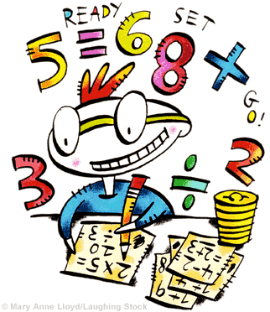
Data Handling - Using technology and other methods, I can display data simply, clearly and accurately by creating tables, charts and diagrams, using simple labelling and scale. MTH 1-21a
Mental Maths - I can use addition, subtraction, multiplication and division when solving problems, making best use of the mental strategies and written skills I have developed. MNU 1-03a
Number Patterns - Through exploring number patterns, I can recognise and continue simple number sequences and can explain the rule I have applied. MTH 1-13b

As part of our Literacy work we will:

Develop our Listening and Talking skills - When I engage with others, I know when and how to listen, when to talk, how much to say, when to ask questions and how to respond with respect. LIT 1-02a
Select appropriate texts to support our own learning - Using what I know about the features of different types of texts, I can find, select, sort and use information for a specific purpose. LIT 1-14a
Focus on editing skills- Throughout the writing process, I can check that my writing makes sense.
LIT 1-23a
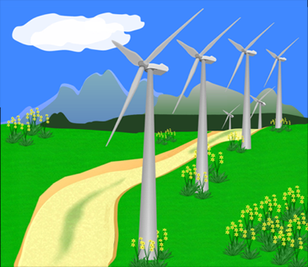
Social Subjects:
Our topic this term is Energy. The pupils will be developing their understanding of what energy is, the different forms energy can take and the different types of energy sources - renewable and non-renewable.

I am aware of different types of energy around me and can show their importance to everyday life and my survival. SCN 1-04a
I can describe an electrical circuit as a continuous loop of conducting materials. I can combine simple components in a series circuit to make a game or model. SCN 1-09a
Throughout all my learning, I take appropriate action to ensure conservation of materials and resources, considering the impact of my actions on the environment. TCH 1-02
Having explored the landscape of my local area, I can describe the various ways in which land has been used. SOC 1-13a

If you work in the Energy sector and would be willing to come into speak to the Primary 4 classes about the different skills involved in your job. This would be greatly appreciated it. A note in your child’s diary of your availability and contact information is all we would need at this stage. ☺

Dates for your diary
- May Day Holiday – Monday 7th May
- Wellbeing Festival – Friday 18th May
- Occasional Day –Monday 4th June
- Sports Day – Friday 8th June
- Alternative Sports Day – Friday 15th June
- PTA Disco – Friday 15th June
- End of Term – Friday 6th July

If there is ever anything you need to discuss please write a note in your child’s home-school book, catch us at the end of the day or contact the school office.
Mrs Bain and Mrs Cordiner

