P4P Newsletter – TERM 2

Dear Parents/Guardians,

Welcome back. I hope you all had an enjoyable October break. Everyone has settled back into class and they are ready for a busy Term.

**Timetable**

Our specialist times this term are as follows:

Tuesday – Drumming with Mrs McIntosh

- Library

Wednesday – Science with Mrs Murray

**P.E**. – This term is a busy time of year for the Hall. The hall time table will change weekly, therefore P.E lessons may take place of different days each week. Please make sure your child has their P.E. kit in school every Monday.

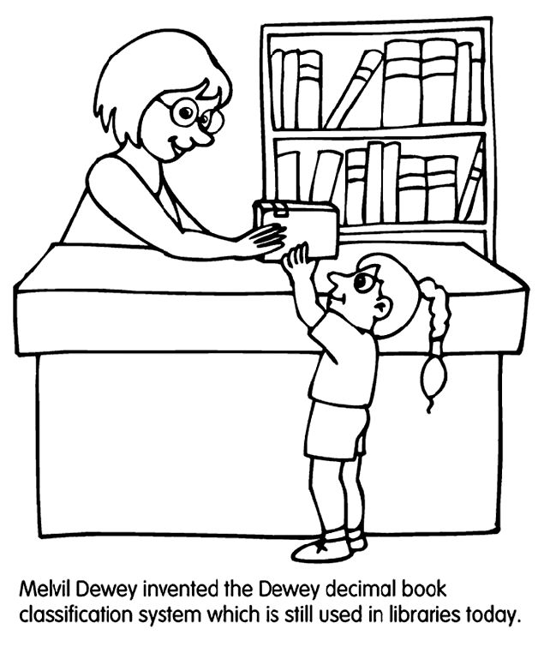**Library**

The class will visit the library every second **Tuesday** of this term.

Dates are as follows: 7th and 21st November and 5th and 19th December. Please check return date stamps in books to ensure books are returned in time.

**Homework and Reading**

Homework will be handed out on a **WEDNESDAY** to be completed and handed in on the **TUEDAY**. Activities will cover a variety of curricular areas and reinforce learning that is taking place in class. Reading times will be shown in your child’s reading record, please remind your child to bring this every day.

**Clothing**

Please could you ensure that all clothing is clearly labelled. Thank you.

**Water bottles and snack**

As in previous years, we encourage the children to bring water bottles (with their name on) to school so that they can drink water during the day. Please remind your child to take their bottle home at the end of the day so that they can be washed for the next day. We have some children with nut allergies in the school. Please encourage your child to take in snacks that are not nut based. Thank you.

**Literacy**

This term in Literacy we will:

* Writing our own play scripts and instructions.

*Having explored the elements which writers use in different genres, I can use what I learn to create my own stories, poems and plays with interesting structures, characters and/or settings.* ***ENG 1-31a***

**Maths**

This term in Maths we will focus on:

* 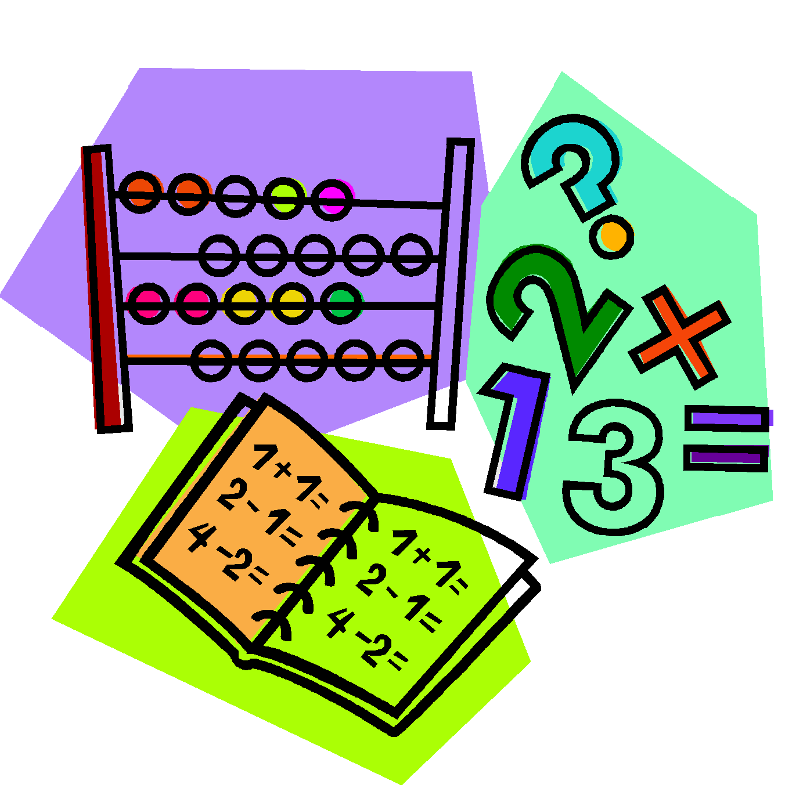Continue to develop and share mental strategies for adding, subtracting, multiplying and dividing up to three digits.
* Written methods of operations within 10,000.

*I can use addition, subtraction, multiplication and division when solving problems, making best use of the mental strategies and written skills I have developed.* ***MNU 1-03a***

* *Use of a range of instruments to estimate and measure and record the weight, capacity, length and area of objects*.

I can estimate how long or heavy an object is, or what amount it holds, using everyday things as a guide, then measure or weigh it using appropriate instruments and units. MNU 1-11a

I can estimate the area of a shape by counting squares or other methods. MNU 1-11b

**Term 2 Topic**

We will continue with our Scotland topic for the first half of this term and then begin a new topic on Lego. Here we will focus on recognising 2D and 3D shapes and how they can be used to visually represent ideas and concepts. Children will have the opportunity to create manual and/or digital sketches to represent their ideas.

I can explore and experiment with sketching, manually or digitally, to represent ideas in different learning contexts. **TCH 1-11a**

I explore and discover engineering disciplines and can create solutions. **TCH 1-12a**

**Dates for your Diary:**

* 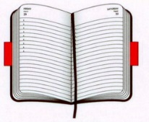Monday 13th and Tuesday 14th November – In-Service Training Days
* Friday 24th November – P4P Assembly
* Friday 1st December – Scoping Jotters sent home.
* Tuesday 19th December – p4/5 Christmas Party

Please always feel free to get in touch with me at school if you have any queries or concerns. I look forward to meeting you soon and working together to support your child.

Thank you

Miss Leat