**P4S Newsletter**

Dear Parents/Guardians,

Welcome back. I hope you all had an enjoyable October break. Everyone has settled back into class and they are ready for a busy Term.

**Our Timetable**

The class will have:

Monday: **Drumming** with Mrs McIntosh

Tuesdays: **Drama** with Mrs McGillivray and **Science** with Mrs Murray

Wednesday: Miss Pauline Donnelly will continue to take the class every Wednesday.

Friday: **Library**

**P.E.** This term is a busy time of year for the hall. The hall timetable will change weekly, therefore P.E. lessons may take place on different days each week. Please make sure your child has their P.E. kit in school every Monday.

We will also have Mrs Smith, Mrs Ritchie, Mrs Black and Mrs Donovan supporting the work we do in class.

MCj04260540000[1]**Library**

The class will visit the library every second Friday. The next three dates are as follows: **17th November, 1st December and 15th December.**

Please check the return date stamps in books to ensure they are returned on time.

**Homework & Reading**

Homework will be handed out on **Wednesday** to be completed and handed in on the **Tuesday**. Activities will cover a variety of curricular areas and reinforce learning that is taking place in class. Reading times will be shown in your child’s homework diary, please remind your child to bring this every day.

**Water Bottles and snacks**

As in previous years, we encourage the children to bring water bottles (with their name on) to school so that they can drink water during the day. Please remind your child to take their water bottle home at the end of the day so that they can be washed for the next day. We have some children with nut allergies in the school. Please encourage your child to take in snacks that are not nut based. Thank you.MC900299627[1]

**Clothing**

Please could you ensure that all clothing is clearly labelled. Thank you.

**Literacy**This term in Literacy we will be:

* Writing our own play scripts and instructions.

*Having explored the elements which writers use in different genres, I can use what I learn to create my own stories, poems and plays with interesting structures, characters and/or settings.* ***ENG 1-31a***

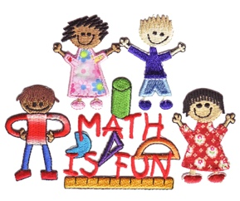

**Maths**  
This term in Maths we will focus on:

* Continue to develop and share mental strategies for adding, subtracting, multiplying and dividing up to three digits.
* Written methods of operations within 10,000.

*I can use addition, subtraction, multiplication and division when solving problems, making best use of the mental strategies and written skills I have developed.* ***MNU 1-03a***

* Use of a range of instruments to estimate and measure and record the weight, capacity, length and area of objects.

I can estimate how long or heavy an object is, or what amount it holds, using everyday things as a guide, then measure or weigh it using appropriate instruments and units. MNU 1-11a

I can estimate the area of a shape by counting squares or other methods. MNU 1-11b

**Term 2 Topic**

We will continue with our Scotland topic for the first half of this term and then begin a new topic on Lego. Here we will focus on recognising 2D and 3D shapes and how they can be used to visually represent ideas and concepts. Children will have the opportunity to create manual and/or digital sketches to represent their ideas.

*I can explore and experiment with sketching, manually or digitally, to represent ideas in different learning contexts.* ***TCH 1-11a***

*I explore and discover engineering disciplines and can create solutions.* ***TCH 1-12a***

**Dates for your Diary:**

* 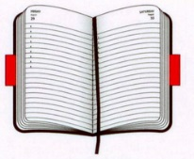Monday 13th and Tuesday 14th November – In-Service Training Days
* Friday 1st December – P4S Assembly and Scoping Jotters sent home.
* Tuesday 19th December – p4/5 Christmas Party

If there is anything you would like to discuss, or information to share about your child, please feel free to contact me either by writing a note in your child’s home/school diary, catching me in the playground at the end of the day or by contacting the school office.

Thank you

**Miss Airlie**