 **P5K Newsletter**

**Session 2017 – 2018**

**Term 4 April – July**

Welcome back and we hope you all had and enjoyable Easter break!   
Due to Mrs East’s absence Mrs Dymond will continue taking the class on Mondays and Tuesdays.

**Timetable**

*Science* with Mrs Murray on Tuesdays

*P.E. w*ith Mrs Strand on Thursday

*Art and Music* will be taught by the class teachers.

Library visits will be every second Thursday **(25th April, 9th and 23rd May, 2nd, 6th and 20th June and 4th July).**   
Please ensure your child returns their book prior to the next visit.

**Homework**

Homework will continue to **be issued on a Thursday and returned on a Tuesday**. Homework will usually consist of a language activity, a maths activity and another piece of work. All homework will be to consolidate what the children are learning in class or to preview future learning. This term the children will also be preparing a personal talk and completing a research project linked to our topic.  
Reading will be given out on the days set to your child’s group. ***We would appreciate if you could sign any homework and reading tasks as an acknowledgement that you have seen them.***

**Numeracy and Literacy**

In Maths this term we will continue to practise our mental agility within our times tables and division, using them in both mental and written strategies to work out a variety of number problems. We will also be working on decimals and percentages, coordinates and revisiting time.   
We will be looking at persuasive, imaginative and report writing through our topic work. The children will be encouraged to add detail to their written work to capture the attention of the reader by adding interesting vocabulary, adjectives, alliteration and examples of similes.

**Health and Wellbeing**

We will be covering Living and Growing lessons this term. The theme of these lessons is Changes and further information will follow. We will also look at ways to keep healthy including a balanced diet, sleep and exercise.

**Topic**

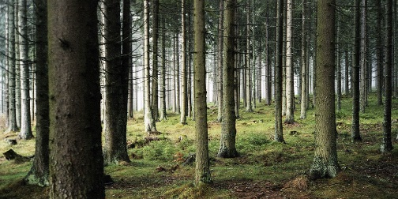Our topic this term is ‘Our World’ and we will be learning about habitats and ecosystems, food webs and animal classification and biodiversity and sustainability within our local environment.   
We plan to use both the school grounds and visits to areas around Kintore to achieve this.

**Reminders**

* [](http://www.google.co.uk/url?url=http://www.clipartsheep.com/rainy-day-clipart/dT1hSFIwY0RvdkwyeGhhMlZ6YUc5eVpXeGxZWEp1YVc1bkxtTnZiUzl0WldScFlTOXBiV0ZuWlhNdlpuSmxaVjl5WlhOdmRYSmpaWE12WTJ4cGNGOWhjblF2YzJWaGMyOXVjeTl5WVdsdWVVUmhlVjkwYmk1bmFXWXx3PTcwfGg9NzB8dD1naWZ8/&rct=j&frm=1&q=&esrc=s&sa=U&ved=0CDIQwW4wDWoVChMIqeqpjpvlyAIVBLoUCh025QNb&usg=AFQjCNGwtl2YoKo2UIqXHHyVzebT6sP-EQ)The classroom can become very warm so it is important that each child **brings their own water bottle** to school if possible. This can be refilled as required in class.
* Please have **a full P.E. kit** available in class at all times. Especially with the nicer weather we would hope to get outside as much as we can.
* Children are encouraged to **bring the appropriate equipment to school** - pencils, rubber, ruler, sharpener, coloured pencils etc, to enable them to complete their work.
* As you know the weather can be changeable at the moment, please ensure that your child **brings a jacket** to school every day.

**  
Important dates**

* 7th May – Holiday
* 4th June – Holiday
* 8th June - Sports Day
* 15th June – alternative sports day
* 15th June - Disco
* 6th July – Last day of term

If you have any questions or would like to discuss anything please do not hesitate to contact either of us at the school or in the playground at the end of the school day.

**We are looking forward to a busy and productive final term with P5K.**

***Mrs Dymond and Mrs Strand***