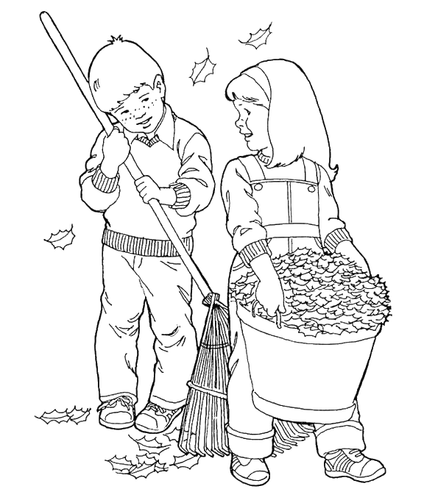
TERM 2 – October 2017

Welcome back to all the children and I hope you all have had a pleasant October break.
The children are full of news about the exciting activities they did during the break and have been sharing these. Term 2 will be a busy and productive term for us.

Timetable
Tuesday – Science with Mrs. Murray
Wednesday – German with Frau Kaup and Art with myself
Thursday – Music with myself
Friday – P.E – Scottish Dancing – with myself

We also have Mrs. Beagrie and Mrs. Smith supporting the work we do in class.

Library
Our library slot this term will be on a Friday. Please remind your child to bring their book in the day before if possible.
Our dates are: - 3rd, 17th November and 1st, 15th December. All books to be returned to class by Thursday 21st December.

Homework
Homework will be issued on a Wednesday to be returned on the following Monday. The tasks will cover a variety of curricular areas and will be reinforcing what the children have been learning in class.
Children will also receive regular reading homework with reading days remaining the same for each group this term. Please remember to sign your child’s homework and reading record.

Term 2 Curriculum
Literacy
Our Writing focus this term is linked to our topic of Enterprise.
- By considering the type of text I am creating, I can select ideas and relevant information, organise these in an appropriate way for my purpose and use suitable vocabulary for my audience. LIT 2-26a
- I can persuade, argue, explore issues or express an opinion using relevant supporting detail and/or evidence.
LIT 2-29a

This term our Class Novel is “The Last Wolf” by Michael Morpurgo. After the success of “George’s Marvellous Medicine”, the children are looking forward to this book too.

Mathematics
Our Maths this term is also linked to our Enterprise Topic and we will be focusing on Money and Data Handling.

- I understand the costs, benefits and risks of using bank cards to purchase goods or obtain cash and realise that budgeting is important. MNU 2-09b
- I can use the terms profit and loss in buying and selling activities and can make simple calculations for this. MNU 2-09c
- I have carried out investigations and surveys, devising and using a variety of methods to gather information and have worked with others to collate, organise and communicate the results in an appropriate way. MNU 2-20b

Our Topic for this term is an Enterprise based topic. Our class will be creating a business with the aim to make a product to sell at our café. The main focus will be
- Developing useful skills for learning life and work.
- Gaining business enterprise skills, knowledge and understanding of the importance and methods of managing finance.

The children will also have a block of Brazilian Samba throughout the year and I am sure they will share this with you.

Dates for your Diary

- 10th November - Halloween Disco (Tickets have been distributed to the children)
- 13th & 14th November – INSET days (children not at school)
- 6th December (am) – Café (details to follow shortly)
- 19th December – P4/5 Christmas Party
- 22nd December – Church Service/Last day of term 2

If there is anything you would like to discuss, or information to share about your child, please feel free to contact me either by writing a note in your child’s home/school notebook, catching me in the playground at the end of the day or by contacting the school office.

Thank you

Mrs Susan Wilson

