**P6P Class Newsletter**

**Term 2, Session 2017/2018**

Welcome back to term two. I hope you all had a restful holiday and are ready for another busy term ahead! We will continue to have Mrs Grant working with us in our class this term as our PSA, in addition to this we will have Mr Gray and Mrs Williamson. Our specialist teachers this term will be Mrs Kaup for Modern Languages, Mrs McIntosh for drumming and Mrs Young will be taking the class for one of their P.E. sessions.

Timetable for the week:

|  |  |
| --- | --- |
| Monday | Library (fortnightly, starting 6th Nov.) |
| Wednesday | French with Ms Kaup |
| Thursday | P.E. (outside) with Mrs Young |
| Friday | Assembly, Drumming (with Mrs McIntosh), Excellence Time |

On a Thursday Mrs Young will be taking the class outside for their P.E. session. Children should bring clothing which is suitable for outdoor activities at this time of year. For example- a long sleeve top, joggers or longer leggings. Trainers which can be worn outside would be advisable.

Dates for your diary:

Friday 3rd November-Village Bonfire

Tuesday 7th November – PTA Meeting

Friday 10th November –PTA Disco

Monday 13th November- In-service- School closed to pupils

Tuesday 14th November- In-service- School closed to pupils

Monday 20th November- Parent Council Meeting

Tuesday 28th November- PTA Meeting

Friday 1st December- Scoping Jotters home

Monday 18th December- P6 and P7 parties

Friday 22nd December- End of term

Monday 8th January- Term 3 begins

Homework:

Please continue to check that your child is completing their reading pages at home. I understand that one to one reading time is perhaps less frequent with older children as they become increasingly independent with their reading. However, ensuring they are keeping up to date with the given pages is much appreciated. Reading homework is given out on Monday and Thursday.

I will continue to put homework on our class’ GLOW page. After a few teething problems last term, I think everyone has a login and password. However, if there are problems accessing the work at home, please let me know and I can provide a printed copy.

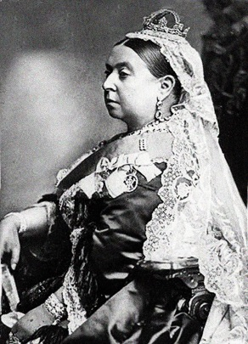Contexts for learning:

This term we will be learning about the Victorian era, and how the people from that time have influenced our lives now. We will be exploring the lives of children, the jobs people did and the advancements in technology that were made. We are keen to find out a bit more about Kintore in the Victorian era and so are asking if anyone has any information at home then we would love to see/read it!

Within maths we will be learning more about fractions, decimals and percentages, building on existing knowledge. We will also be continuing to improve our mental maths strategies (any extra multiplication and division practice at home wouldn’t go amiss!) Additionally we will be learning about shape and continuing to improve our problem solving skills.

Our literacy work will be mostly inspired by our topic, and we will be learning to write reports and learn new techniques for creative writing. In Reading we will be learning to skim and scan a text and to highlight useful information to use in report writing.

As always, if you have any concerns you are welcome to write informal notes to me in your child’s planner or if more time is needed to discuss an issue, a time can be arranged for after school.

Thanks again for your continued support,

Lyndsey Paterson