

ACTIVE SCHOOLS OCTOBER PROGRAMME

P1-7 Multi-Sports Activity Programme:-

Tuesday 17th Oct and Thursday 19th Oct

*10am – 1pm each day @ Kemnay Academy*

*Cost = £6 per day*

Judo and Games with Garioch Judo Club:-

**

Tuesday 24th October

*P1-7 – 10am-3pm @ Kemnay Academy*

*Cost = £20 for full day*

*Sign up directly with Garioch Judo Club* [*stuartmcwatt@hotmail.com*](mailto:stuartmcwatt@hotmail.com)

Hip Hop with MC:-

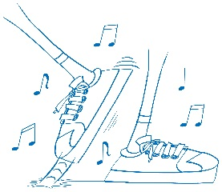Wednesday 25th October

*P1-3: 10am-11am, P4-7: 11am-12pm, and S1 upwards: 12pm-1pm*

*@Kemnay Academy*

*Cost = £3*

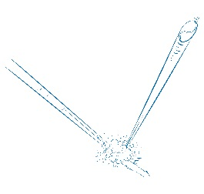Tennis with Vikki:-

Thursday 26th October

*P1-3: 1pm-2:30pm, P4-7: 2:30pm-4pm @ Kemnay Academy*

*Cost = £4*

For information regarding booking, please see reverse of leaflet.







***Spaces are limited and must be booked before Monday 16th October!***

Booking Procedure:-

In order for your child to attend the holiday programme activity sessions you must ensure you sign up via one of the following methods:

Online application form: <http://www.aberdeenshire.gov.uk/request/active-schools/active-schools-online-form-garioch-holiday-programme/>

Call: Lynsey Coutts on 01467 538899 / 07909 875461

or Email: [lynsey.coutts@aberdeenshire.gov.uk](mailto:lynsey.coutts@aberdeenshire.gov.uk)

*If your child has previously attended an Active Schools club/session, and contact details have not changed, then please call or email to book your child’s space at the programme*

Payment:

Please bring payment in a sealed envelope with your child’s name and school clearly marked on the front. **Please bring payment on the first day your child is attending the programme.**

Cheques can be made payable to “Aberdeenshire Council”.

*Free of charge for Active Aberdeenshire Members*

