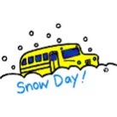Snow Day Activities - Primary 2
If school is closed or school transport is not operating due to poor weather conditions, please choose some activities to complete each day that you are not in school.
Technology/ICT  - Use your recycling to make a snow mobile that we hang in the classroom.  - Draw a picture of a super sledge and label what it can do.  - Design a winter home for an animal. Draw and label it.  - Complete some activities and games on the following websites… www.topmarks.co.uk  www.funbrain.com www.bbc.co.uk/schools | Literacy  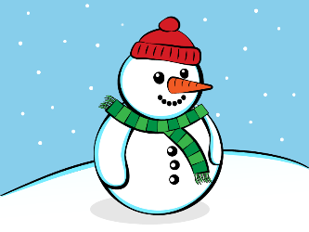  - Write a story about a snowman you have made, include information about what happened first, next and finally. Or write a set of instructions on how to build a snowman.  - Create a new ending for a story you have read.  - Make a new Talking Box about what you did on your snow days.
Other  - Using a song of your choice create an exercise routine that will warm up all your muscles. Share your routine with your friends.  - Create a giant picture in the snow. This might involve sculpting the snow or clearing snow away. If possible take a photo of your work.  - Fill 2 containers with snow. Cover one with something like a towel etc. Which one do you think will melt the quickest? Check your snow after a while and which one melted first. | Numeracy  - Draw pictures or record in your jotter what you did at different hours of the day. Can you write o’clock or half past time- example: 9 o’clock eating breakfast, 10.30am playing in the snow.  - Get an adult to give you a number. Make as many number stories as you can. For example 12… (6 + 6, 10 + 2, 14 – 2 etc.). Can you use a bigger number each day?  - Make some patterns in the snow and draw them in your jotter.  - Build a snowman and measure how tall it is.  - Log onto Sumdog and see how well you can do. Your username and password is in your homework jotter. www.sumdog.com

