

Welcome to P3/4!
My name is Mrs Gemma Morrison and I will be teaching P3/4 for term 1 this year. Most of the class already know me from my time as a P2 teacher and this has helped us to settle in quickly to our new class.

Our Teachers  This term we have two other teachers helping us with our learning throughout the week.  Tuesday: R.M.E and Problem …………..Solving with Mrs Donnelly  Thursday: Drama with  ……………Mrs MacGillivray | Dates for Diary  Fri 31st of August: Open Afternoon 1.45-2.45pm  Tues 2nd of October: Parent’s Twilight 3.30 – 5.30pm  Thurs 4th of October: Parent’s Evening 6.30 – 8.30pm  * If you have any special requests for date or time of appointment please put these in writing as soon as possible.
Weekly Routines
Monday: P.E. Kits + Homework returned
Wednesday: Homework out
+ Library – we had our first visit during the first week of term, so our next ………………..visit will be on the 6th of September and every second week following.
Reminders
- It can always be tricky keeping track of everyone’s belongings and it is really appreciated when they are labelled clearly to allow for quick return.
- It is helpful if families could provide an apron or adult-sized t-shirt to protect uniforms during our Art lessons. We do have a limited number of these in class, but they are not always a suitable size.

Homework and Reading
This term homework will be issued on a Wednesday to be returned on or before the following Monday. Activities will include a Numeracy and Literacy task each week and reinforce learning that is taking place in class. Please complete the feedback on your child’s homework sheet and I welcome any further comments to ensure that homework tasks are productive and helpful to each child’s learning.
Each child has a Reading Record which will show you what they are to read at home and when it should be read by. Again, please sign their diaries to show they have completed their reading with you and any comments you wish to share.
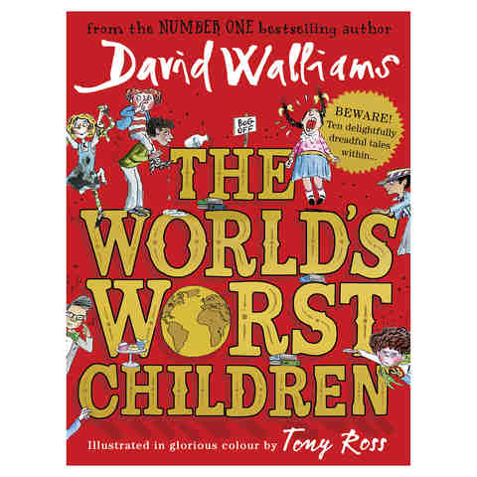
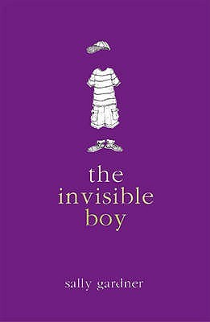
Class Novel Study
This term we will be taking our topic context from the children’s novels ‘The Invisible Boy’ by Sally Gardner and ‘The World’s Worst Children’ by David Walliams. This allows us to introduce and practise key Literacy skills, such as summarising, sequencing and exploring characterisation/setting, that will continue to be used throughout the year. The stories also provide a context for skills in other curricular areas, such as Health & Wellbeing, I.C.T, Drama and Numeracy.

As always, should you wish to discuss anything at all with me please, please do not hesitate to get in touch through the school office or your child’s home/school diary.

Thank you for your support,
Mrs Morrison & Primary 3/4

