na00862_

**Term 1 Primary 5S Newsletter ☺**

Dear parents/ guardians,

My name is Mrs Dymond and I am delighted to be teaching P5S this year. I hope everyone has enjoyed the summer break and are looking forward to a busy year ahead! It has been great getting to know the children over the last couple of weeks as they settle into the class. Below is some information to help you and your child this term.

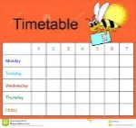**Timetable**

Monday – Library

Wednesday - P.E., Science and Problem Solving with Mrs Johnstone

Friday – P.E. with Mrs Dymond

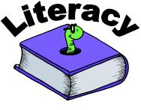**Literacy**

This term, will be focusing on poetry, imaginative and instructional writing linked to our class novel, ‘The Iron Man’. In Reading, we will be working on our summarisation and prediction skills as well as oral reading skills.

**Library**

Library visits will be every second Monday.

**3rd September, 17th September and 1st October**

**Maths**

****In Maths we will focus on mental agility and will continue to develop their written and mental strategies for adding, subtracting, multiplying and dividing. We will take part in daily mental maths sessions to improve speed and accuracy. We will also be focusing on place values of digits including decimal values and using mental maths knowledge to support the learning and understanding of expressions and equations.

**Topic**

Our Topic this term is based on the novel ‘The Iron Man’ by Ted Hughes. Through this we will look at components used in electrical circuits and the children will draw and create circuits using diagrams and symbols. We will also look at robot art created by Eric Joyner.

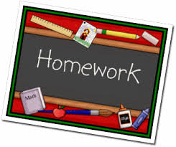**Homework**

Homework will be issued on a **Thursday** and is expected to be completed and returned the following **Tuesday.** The class are also required to read their reading book in school. The pages they are required to read for homework will be recorded in their home-school diary.

**P.E.**

The children will have two PE sessions a week. Please ensure that your child has a full PE kit every day in case we have an additional PE slot. Please ensure all items of clothing are named to avoid confusion over ownership.

**Water and Snack**

We encourage the children to bring water bottles to school so that they can drink water during the day. To encourage healthy eating, the school's Golden Carrot competition continues. Children are encouraged to bring a healthy snack Monday to Thursday and to leave Friday as a treat day! Please refrain from giving your child peanut and nut based snacks as there are children with severe nut allergies in school.

**Dates for your diary**

* Friday 31st August – Open afternoon – 1.45pm-2.45pm
* Tuesday 2nd October – Parents’ Meetings – details and times to follow
* Thursday 4th October- Parents’ Meetings – details and times to follow
* Friday 12th of October – End of Term

We have made a very good start to P5 and I look forward to sharing our learning experiences with you over the year!

Mrs Dymond