Snow Day Activities – Primary 1 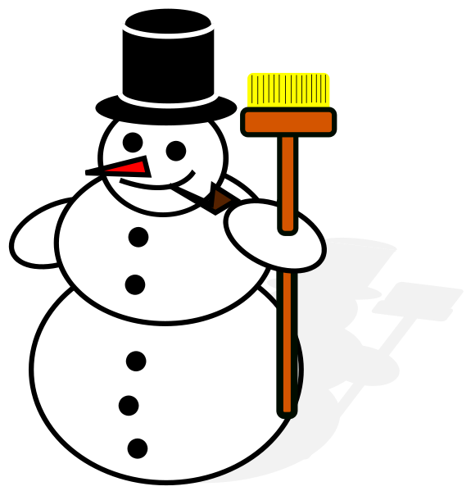
If school is closed or school transport is not operating due to poor weather conditions, please choose 3 activities to complete each day that you are not in school.
Keep a snow day diary explaining what you do on each day you are not in school.

- Make a snowman and take a photograph to share with the class. How tall can you make your snowman?
- Your snowman is magical and has gone on an adventure! What happens to it? Write a story to share with the class.
- Practise writing numbers 0 to 10 – you can write these on paper, in the snow, in bubbles, in shaving foam, in rice. Take some photographs of your number work!
- Hunt for different objects to use for counting. For example, if your target number is 7, make seven snowballs. Draw pictures or take photographs of what you have counted.
- Can you make addition sums in the snow? Show your findings in a photo or picture.
- How many words can you think of using the sounds that are in your name? For example, BEN = bed. boot, baby, egg, elephant, envelope, nose, net, nurse. Write these out either in the snow or on paper.
- Practise writing words using the sounds you now know eg cat, bat, rat etc.
- Make a paper snowflake and decorate it.
- Draw a picture of what you can see out of your bedroom window. Write about what has changed.
- Design a fancy pair of wellies using a repeating pattern.
- Draw a picture of yourself in your winter clothes. Label what you are wearing.
- Watch your favourite television programme and draw a picture about it. Tell us why it is your favourite television programme.
- How many snowballs can you make in a minute?
- Cook or bake something yummy to eat with an adult.
- Read a book and draw what you could see, hear, touch, smell and taste if you were a character in the story.
- Play a board game with the people in your house. This will help you practise how to take turns sensibly.
- Look for animal footprints in the snow. Can you guess who has made them? Draw the footprints and the animal that made them.
- Can you make a snow den for a fairy or an elf? Describe it and write about a short adventure it goes on.
- Can you do star jumps in the snow, if so how many can you do in a minute?
- Put snow into 2 different cups and put one near a window and one near a heater. Keep a look out to see which one melts first?
- Design a vehicle for you to travel about in the snow.
Snow Day Activities – Primary 1
If school is closed or school transport is not operating due to poor weather conditions, please choose 3 activities to complete each day that you are not in school.
Keep a snow day diary explaining what you do on each day you are not in school.

- Make a snowman and take a photograph to share with the class. How tall can you make your snowman?
- Your snowman is magical and has gone on an adventure! What happens to it? Write a story to share with the class.
- Practise writing numbers 0 to 10 – you can write these on paper, in the snow, in bubbles, in shaving foam, in rice. Take some photographs of your number work!
- Hunt for different objects to use for counting. For example, if your target number is 7, make seven snowballs. Draw pictures or take photographs of what you have counted.
- Can you make addition sums in the snow? Show your findings in a photo or picture.
- How many words can you think of using the sounds that are in your name? For example, BEN = bed. boot, baby, egg, elephant, envelope, nose, net, nurse. Write these out either in the snow or on paper.
- Practise writing words using the sounds you now know eg cat, bat, rat etc.
- Make a paper snowflake and decorate it.
- Draw a picture of what you can see out of your bedroom window. Write about what has changed.
- Design a fancy pair of wellies using a repeating pattern.
- Draw a picture of yourself in your winter clothes. Label what you are wearing.
- Watch your favourite television programme and draw a picture about it. Tell us why it is your favourite television programme.
- How many snowballs can you make in a minute?
- Cook or bake something yummy to eat with an adult.
- Read a book and draw what you could see, hear, touch, smell and taste if you were a character in the story.
- Play a board game with the people in your house. This will help you practise how to take turns sensibly.
- Look for animal footprints in the snow. Can you guess who has made them? Draw the footprints and the animal that made them.
- Can you make a snow den for a fairy or an elf? Describe it and write about a short adventure it goes on.
- Can you do star jumps in the snow, if so how many can you do in a minute?
- Put snow into 2 different cups and put one near a window and one near a heater. Keep a look out to see which one melts first?
- Design a vehicle for you to travel about in the snow.

